​
​
UNITED STATES
SECURITIES AND EXCHANGE COMMISSION
WASHINGTON, D.C. 20549
​
FORM 8-K
​
CURRENT REPORT
​
Pursuant to Section 13 or 15(d) of the Securities Exchange Act of 1934
​
Date of Report (Date of earliest event reported): August 6, 2026

METAVIA INC.
(Exact name of Registrant as Specified in Its Charter)
​

​ | ​ | ​ | ​ | ​
Delaware | ​ | 001-37809 | ​ | 47-2389984
(State or other jurisdiction  of incorporation) | ​ | (Commission  File Number) | ​ | (IRS Employer  Identification No.)
​
​

​  ​  ​ | ​
545 Concord Avenue, Suite 210  Cambridge, Massachusetts  ​ | ​ | 02138
(Address of principal executive offices) | ​ | (Zip Code)
​
(857) 702-9600
(Registrant’s telephone number, including area code)
​
Not applicable
(Former name or former address, if changed since last report)
​
Check the appropriate box below if the Form 8-K filing is intended to simultaneously satisfy the filing obligation of the registrant under any of the following provisions:
​

​ | ​
☐ | Written communications pursuant to Rule 425 under the Securities Act (17 CFR 230.425)
☐ | Soliciting material pursuant to Rule 14a-12 under the Exchange Act (17 CFR 240.14a-12)
☐ | Pre-commencement communications pursuant to Rule 14d-2(b) under the Exchange Act (17 CFR 240.14d-2(b))
☐ | Pre-commencement communications pursuant to Rule 13e-4(c) under the Exchange Act (17 CFR 240.13e-4(c))
​
Securities registered pursuant to Section 12(b) of the Act:
​

​ | ​ | ​  ​ | ​ | ​
Title of each class | ​ ​ ​ | Trading  Symbol(s) | ​ ​ ​ | Name of each exchange on which registered
Common Stock, par value $0.001 per share |  | MTVA |  | The Nasdaq Stock Market LLC
​
Indicate by check mark whether the registrant is an emerging growth company as defined in Rule 405 of the Securities Act of 1933 (§ 230.405 of this chapter) or Rule 12b-2 of the Securities Exchange Act of 1934 (§ 240.12b-2 of this chapter).
​
Emerging growth company ☐
​
If an emerging growth company, indicate by check mark if the registrant has elected not to use the extended transition period for complying with any new or revised financial accounting standards provided pursuant to Section 13(a) of the Exchange Act. ☐
​
​
​
​
​
​
Item 2.02.Results of Operations and Financial Condition.
On August 6, 2026, MetaVia Inc. (the “Company”) issued a press release announcing its financial results for the second quarter ended June 30, 2026 and providing a corporate update. A copy of the press release is furnished herewith as Exhibit 99.1 to this Current Report on Form 8-K (this “Report”).
​
Item 7.01.Regulation FD Disclosure.
On August 6, 2026, the Company posted an updated corporate presentation to its website at https://ir.metaviatx.com/events-presentations/presentations, which the Company may use from time to time in connection with presentations, investor communications or conferences. A copy of the corporate presentation is attached as Exhibit 99.2 to this Report and is incorporated herein by reference.
Information contained on or accessible through any website reference in the press release or the corporate presentation is not part of, or incorporated by reference in, this Report, and the inclusion of such website addresses in this Report by incorporation by reference of the press release and the corporate presentation is as inactive textual references only.
The information in this Report, including Exhibits 99.1 and 99.2 attached hereto, are furnished pursuant to Item 2.02 and Item 7.01, respectively, and shall not be deemed “filed” for purposes of Section 18 of the Securities Exchange Act of 1934, as amended (the “Exchange Act”), or otherwise subject to the liabilities of that Section, nor shall it be deemed incorporated by reference in any filing under the Securities Act of 1933, as amended, or the Exchange Act, except as expressly set forth by specific reference in such filing. The Company’s submission of this Report shall not be deemed an admission as to the materiality of any information required to be disclosed solely to satisfy the requirements of Regulation FD.
Forward-Looking Statements
Exhibits 99.1 and 99.2 attached hereto contain forward-looking statements within the meaning of the federal securities laws. These forward-looking statements are based on current expectations and are not guarantees of future performance. Further, the forward-looking statements are subject to the limitations listed in Exhibits 99.1 and 99.2 and in the other reports of the Company filed with the Securities and Exchange Commission, including that actual events or results may differ materially from those in the forward-looking statements.
​
Item 9.01.Financial Statements and Exhibits.
(d) Exhibits
​ | ​ | ​
Exhibit  Number | ​ ​ ​ | Exhibit Description
99.1 | ​ | Press Release dated August 6, 2026.
99.2 | ​ | Corporate Presentation, August 2026.
104 | ​ | Cover Page Interactive Data File (embedded within Inline XBRL document).
​
​
​
Signatures
​
Pursuant to the requirements of the Securities Exchange Act of 1934, the registrant has duly caused this report to be signed on its behalf by the undersigned hereunto duly authorized.
​
​ | ​ | ​ | ​
​ | ​ ​ ​ | METAVIA INC.
​ | ​ | ​
​ | ​ | ​
Date: August 6, 2026 | ​ | By: | /s/ Hyung Heon Kim
​ | ​ | ​ | Hyung Heon Kim
​ | ​ | ​ | President and Chief Executive Officer
​
​
​

Exhibit 99.1
​
​
​
​
MetaVia Reports Second Quarter 2026 Financial Results and Provides Corporate Update
​
All Active Patients Successfully Reached Highest Planned Dose Levels of 48 mg and 64 mg in Ongoing Phase 1 Part 3 Study of DA-1726
​
16-Week Topline Data Expected in the Fourth Quarter of 2026
​
CAMBRIDGE, Mass., August 6, 2026 – MetaVia Inc. (Nasdaq: MTVA), a clinical-stage biotechnology company focused on transforming cardiometabolic diseases, today announced financial results for the second quarter ended June 30, 2026, and provided a corporate strategic update.
​
“During the second quarter of 2026, and subsequently, we continued to execute across both of our clinical development programs while further strengthening the differentiated profile of DA-1726 as a dual GLP-1/glucagon receptor agonist,” stated Hyung Heon Kim, President and Chief Executive Officer of MetaVia. “Most recently, all active patients in both cohorts of our ongoing Phase 1 Part 3 study successfully reached the highest planned dose levels of 48 mg and 64 mg, representing an important execution milestone as we prepare for our 16-week topline data readout, expected in the fourth quarter of 2026. Also of note, during the quarter, we presented additional data from our 48 mg Phase 1 study of DA-1726 at both the EASL and ADA scientific conferences, which demonstrated up to 9.1% mean weight loss after just eight weeks of treatment, meaningful reductions in waist circumference and encouraging liver-related findings, reinforcing our confidence in DA-1726's potential best-in-class profile and its potential to address multiple aspects of cardiometabolic disease. Based on the continued trajectory of weight loss through eight weeks without evidence of plateau on the 48 mg dosage, we believe the ongoing 16-week study evaluating the 48 mg and higher 64 mg dosages has the potential to provide a more complete assessment of the drug’s effects on weight loss, waist circumference, cardiometabolic health and liver-related outcomes.”
“In parallel, we continued to broaden the potential clinical utility of vanoglipel (DA-1241). During the quarter, we presented preclinical combination data at the ADA 2026 Scientific Sessions, demonstrating synergistic effects with both resmetirom in MASH and metformin in type 2 diabetes, while a peer-reviewed publication further highlighted the anti-fibrotic potential of GPR119 agonism. Together, these findings reinforce our strategy of advancing vanoglipel as a differentiated combination backbone for metabolic and liver diseases, designed to complement established and emerging therapies across cardiometabolic disorders.”
​
Second Quarter 2026 and Subsequent Highlights
​
● | July 2026: Announced the completion of dose titration in the 16-week, Phase 1 Part 3 study of DA-1726, with all active patients successfully reaching the highest planned dose levels of 48 mg and 64 mg.
● | June 2026: Presented new late-breaking data at the ADA 2026 Scientific Sessions supporting DA-1726's differentiated obesity profile and demonstrating the combination potential of vanoglipel with resmetirom in MASH and metformin in type 2 diabetes.

● | May 2026: Presented additional data from the 48 mg Phase 1 trial of DA-1726 at EASL Congress 2026, demonstrating up to 9.1% mean body weight reduction without evidence of plateau and exploratory improvements in liver-related biomarkers, supporting the potential of DA-1726 in obesity and MASH.
● | May 2026: Announced the publication of peer-reviewed preclinical research in Biomolecules & Therapeutics, supporting the anti-fibrotic potential of vanoglipel and the differentiated role of GPR119 agonism in MASH.
● | April 2026: Dosed the first patient in Part 3 of the 16-week Phase 1 clinical trial evaluating DA-1726 in obese, otherwise healthy adults using one-step titration to 48 mg and two-step titration to 64 mg to safely achieve higher target doses and optimize tolerability.
​
Anticipated Clinical Milestones
​
● | DA-1726 in Obesity:
 | o | Data readout from Phase 1 Part 3, 16-week titration studies, evaluating titration to 48 mg in one step and 64 mg via a two-step regimen, is expected in the fourth quarter of 2026.
● | Vanoglipel (DA-1241) in MASH:
 | o | The Company is currently working to schedule an End-of-Phase 2 meeting with the FDA during the second half of 2026 to discuss the clinical development pathway for the vanoglipel combination therapy.
​
Second Quarter Financial and Operating Results
​
● | Research and Development (R&D) Expenses were approximately $3.5 million for the second quarter ended June 30, 2026, as compared to approximately $2.3 million for the second quarter ended June 30, 2025. The increase of approximately $1.2 million was primarily attributable to higher direct R&D expenses related to DA-1726 product development.
​
R&D expenses were approximately $5.6 million for the six months ended June 30, 2026, as compared to approximately $4.6 million for the six months ended June 30, 2025. The approximately $0.9 million increase was primarily attributable to $1.2 million in higher direct R&D expenses related to DA-1726 product development, partially offset by (i) $0.2 million in lower direct R&D expenses related to vanoglipel product development and (ii) $0.1 million in lower indirect employee compensation and benefits costs.
​
● | General and Administrative (G&A) Expenses were approximately $1.9 million for the second quarter ended June 30, 2026, as compared to approximately $2.0 million for the second quarter ended June 30, 2025. The approximately $0.1 million decrease was primarily attributable to lower legal and professional fees.
​
G&A expenses were approximately $3.8 million for the six months ended June 30, 2026, as compared to approximately $3.5 million for the six months ended June 30, 2025. The approximately $0.3 million increase was primarily attributable to (i) $0.1 million in higher consulting expenditures, (ii) approximately $0.1 million in higher employee compensation and benefits costs, and (iii) $0.1 million in higher other G&A expenses, which was primarily related to higher franchise tax expenses.
​

● | Total Operating Expenses were approximately $5.4 million for the second quarter ended June 30, 2026, compared to approximately $4.3 million for the second quarter ended June 30, 2025. The approximately $1.1 million increase was primarily attributable to higher R&D expenses and was partially offset by lower G&A expenses.
​
Total operating expenses were approximately $9.4 million for the six months ended June 30, 2026, compared to approximately $8.2 million for the six months ended June 30, 2025. The approximately $1.2 million increase was primarily attributable to higher R&D and G&A expenses for the six months ended June 30, 2026.
​
● | Total Other Income was approximately $0.1 million for the three months ended June 30, 2026, as compared to approximately $0.3 million for the three months ended June 30, 2025. The approximately $0.2 million decrease was primarily attributable to an approximately $0.2 million negative impact from the change in fair value of warrant liabilities due to the impact of its common stock’s decline in stock price and approximately $0.1 million in lower interest income, net, due to lower balances of cash and cash equivalents and lower interest rates.
​
Total other income was approximately $0.3 million for the six months ended June 30, 2026, as compared to approximately $0.5 million for the six months ended June 30, 2025. The approximately $0.2 million decrease was primarily attributable to (i) $0.1 million in lower gain from change in fair value of warrant liabilities due to the impact of the Company’s common stock’s decline in stock price and (ii) $0.1 million in lower interest income, net, due to lower balances of cash and cash equivalents and lower interest rates.
​
● | Net Loss was $5.3 million, or $0.90 per basic and diluted share, for the second quarter ended June 30, 2026 based on 5,931,875 weighted average shares of common stock outstanding, compared with a net loss of $4.0 million, or $2.87 per basic and diluted share, based on 1,389,753 weighted average shares of common stock outstanding for the second quarter ended June 30, 2025.
​
Net loss for the six months ended June 30, 2026, was approximately $9.1 million, or $1.69 per basic and diluted share, based on 5,398,683 weighted average shares of common stock, basic and diluted, compared with a net loss of approximately $7.7 million, or $6.59 per basic and diluted share, based on 1,162,692 weighted average shares of common stock, basic and diluted, for the six months ended June 30, 2025.
​
● | Cash and cash equivalents was $12.6 million as of June 30, 2026, compared with $10.3 million as of December 31, 2025. The company expects its cash position will be adequate to fund operations through 2026.
​
About MetaVia
MetaVia Inc. is a clinical-stage biotechnology company focused on transforming cardiometabolic diseases. The company is currently developing DA-1726 for the treatment of obesity, and is developing vanoglipel (DA-1241) for the treatment of Metabolic Dysfunction-Associated Steatohepatitis (MASH). DA-1726 is a novel oxyntomodulin (OXM) analogue that functions as a glucagon-like peptide-1 receptor (GLP1R) and glucagon receptor (GCGR) dual agonist. OXM is a naturally-occurring gut hormone that activates GLP1R and GCGR, thereby decreasing food intake while increasing energy expenditure, thus potentially resulting

in superior body weight loss compared to selective GLP-1 receptor agonists such as semaglutide. In a Phase 1 multiple ascending dose (MAD) trial in obesity, DA-1726 demonstrated best-in-class potential for weight loss, glucose control, and waist reduction. Vanoglipel is a potential first-in-class drug candidate targeting G-protein-coupled receptor 119 (GPR119). In preclinical studies, vanoglipel demonstrated a positive metabolic effect on glucose and lipid control, and also proved differentiated hepatic benefits reducing hepatic steatosis, hepatic inflammation, and liver fibrosis independent of metabolic improvement. In a Phase 2a clinical study, vanoglipel demonstrated direct hepatic action in addition to its glucose lowering effects.
​
For more information, please visit www.metaviatx.com.
​
Forward Looking Statements
Certain statements in this press release may be considered forward-looking statements within the meaning of the Private Securities Litigation Reform Act of 1995. Words such as "believes", "expects", "anticipates", "may", "will", "should", "seeks", "approximately", “potential”, "intends", "projects", "plans", "estimates" or the negative of these words or other comparable terminology (as well as other words or expressions referencing future events, conditions or circumstances) are intended to identify forward-looking statements. Forward-looking statements are predictions, projections and other statements about future events that are based on current expectations and assumptions and, as a result, are subject to risks and uncertainties. Many factors could cause actual future events to differ materially from the forward-looking statements in this press release, including, without limitation, those risks associated with MetaVia's history of net losses, the sufficiency of its existing cash on hand to fund operations and raising additional capital; adverse global economic conditions; MetaVia’s ability to execute on its commercial strategy; the timeline for regulatory submissions; the ability to obtain regulatory approval through the development steps of MetaVia's current and future product candidates; the ability to realize the benefits of the license agreement with Dong-A ST Co. Ltd., including the impact on future financial and operating results of MetaVia; the cooperation of MetaVia's contract manufacturers, clinical study partners and others involved in the development of MetaVia's current and future product candidates; potential negative interactions between MetaVia's product candidates and any other products with which they are combined for treatment; MetaVia's ability to initiate and complete clinical trials on a timely basis; MetaVia's ability to recruit subjects for its clinical trials; whether MetaVia receives results from MetaVia's clinical trials that are consistent with the results of preclinical and previous clinical trials; impact of costs related to the license agreement, known and unknown, including costs of any litigation or regulatory actions relating to the license agreement; the effects of changes in applicable laws, regulations or Nasdaq listing rules; the effects of changes to MetaVia's stock price; and other risks and uncertainties described in MetaVia's filings with the Securities and Exchange Commission, including MetaVia's most recent Annual Report on Form 10-K. Forward-looking statements speak only as of the date when made. MetaVia does not assume any obligation to publicly update or revise any forward-looking statements, whether as a result of new information, future events or otherwise, except as required by law.
​
Contacts:
MetaVia
Marshall H. Woodworth
Chief Financial Officer
+1-857-299-1033
marshall.woodworth@metaviatx.com

​
Rx Communications Group
Michael Miller
+1-917-633-6086
mmiller@rxir.com
​
- Tables to Follow -
​

MetaVia Inc.
Condensed Consolidated Balance Sheets
(Unaudited - In thousands, except share and per share amounts)
​
​
​ | ​ | ​ | ​ | ​ | ​ | ​
​ | ​ | As of
​ | ​ | June 30, 2026 |  | ​ | December 31, 2025
Assets | ​ | ​ | ​ | ​ | ​ | ​
Current assets | ​ | ​ | ​ | ​ | ​ | ​
Cash and cash equivalents | ​ | $ | 12,634 | ​ | $ | 10,278
Prepaid expenses and other current assets | ​ | ​ | 433 | ​ | ​ | 597
Total current assets | ​ |  | 13,067 | ​ |  | 10,875
Property and equipment, net | ​ |  | 8 | ​ |  | 17
Right-of-use asset | ​ | ​ | 175 | ​ | ​ | 210
Other assets | ​ | ​ | 21 | ​ | ​ | 21
Total assets | ​ | $ | 13,271 | ​ | $ | 11,123
Liabilities and stockholders’ equity | ​ | ​ | ​ | ​ | ​ | ​
Current liabilities | ​ | ​ | ​ | ​ | ​ | ​
Accounts payable | ​ | $ | 921 | ​ | $ | 1,060
Clinical trial accrued liabilities | ​ | ​ | 2,825 | ​ | ​ | 79
Accrued expenses and other current liabilities | ​ |  | 606 | ​ |  | 993
Warrant liabilities | ​ | ​ | 23 | ​ | ​ | 136
Related party payable | ​ | ​ | 1,897 | ​ | ​ | 3,312
Lease liability, short-term | ​ | ​ | 74 | ​ | ​ | 68
Total current liabilities | ​ |  | 6,346 | ​ |  | 5,648
Lease liability, long-term | ​ | ​ | 103 | ​ | ​ | 142
Total liabilities | ​ |  | 6,449 | ​ |  | 5,790
Commitments and contingencies | ​ | ​ | ​ | ​ | ​ | ​
Stockholders’ equity | ​ | ​ | ​ | ​ | ​ | ​
Preferred stock, $0.001 par value per share; 10,000,000 shares authorized and no shares issued or outstanding as of June 30, 2026 and December 31, 2025 | ​ | ​ | — | ​ | ​ | —
Common stock, $0.001 par value per share, 100,000,000 shares authorized as of June 30, 2026 and December 31, 2025; 6,575,656 and 2,308,294 shares issued and outstanding as of June 30, 2026 and December 31, 2025, respectively | ​ |  | 7 | ​ |  | 2
Additional paid–in capital | ​ |  | 164,784 | ​ |  | 154,161
Accumulated deficit | ​ |  | (157,969) | ​ |  | (148,830)
Total stockholders’ equity | ​ |  | 6,822 | ​ |  | 5,333
Total liabilities and stockholders’ equity | ​ | $ | 13,271 | ​ | $ | 11,123
​
​

MetaVia Inc.
Condensed Consolidated Statements of Operations
(Unaudited - In thousands, except share and per share amounts)
​
​ | ​ | ​ | ​ | ​ | ​ | ​ | ​ | ​ | ​ | ​ | ​ | ​
​ | ​ | Three Months Ended June 30, |  |  |  |  | ​ | Six Months Ended June 30,
​ | ​ | 2026 |  | ​ | 2025 |  | ​ | 2026 |  | ​ | 2025
Operating expenses | ​ ​ ​ | ​ | ​ | ​ ​ ​ | ​ | ​ | ​ ​ ​ | ​ | ​ | ​ ​ ​ | ​ | ​
Research and development | ​ | $ | 3,478 | ​ | $ | 2,320 | ​ | $ | 5,579 | ​ | $ | 4,647
General and administrative | ​ | ​ | 1,907 | ​ | ​ | 1,981 | ​ | ​ | 3,831 | ​ | ​ | 3,540
Total operating expenses | ​ |  | 5,385 | ​ |  | 4,301 | ​ |  | 9,410 | ​ |  | 8,187
Loss from operations | ​ |  | (5,385) | ​ |  | (4,301) | ​ |  | (9,410) | ​ |  | (8,187)
Other income (expense) | ​ | ​ | ​ | ​ | ​ | ​ | ​ | ​ | ​ | ​ | ​ | ​
(Loss) gain from change in fair value of warrant liabilities | ​ | ​ | (4) | ​ | ​ | 160 | ​ | ​ | 113 | ​ | ​ | 247
Interest income, net | ​ | ​ | 73 | ​ | ​ | 146 | ​ | ​ | 158 | ​ | ​ | 274
Total other income | ​ | ​ | 69 | ​ | ​ | 306 | ​ | ​ | 271 | ​ | ​ | 521
Loss before income taxes | ​ | ​ | (5,316) | ​ | ​ | (3,995) | ​ | ​ | (9,139) | ​ | ​ | (7,666)
Provision for income taxes | ​ | ​ | — | ​ |  | — | ​ | ​ | — | ​ |  | —
Net loss | ​ |  | (5,316) | ​ |  | (3,995) | ​ |  | (9,139) | ​ |  | (7,666)
Loss per share of common stock, basic and diluted | ​ | $ | (0.90) | ​ | $ | (2.87) | ​ | $ | (1.69) | ​ | $ | (6.59)
Weighted average shares of common stock, basic and diluted | ​ |  | 5,931,875 | ​ | ​ | 1,389,753 | ​ |  | 5,398,683 | ​ | ​ | 1,162,692
​

Exhibit 99.2
 |  | 1 MetaVia Inc. Transforming Cardiometabolic Diseases Investor Presentation August 2026 www.metaviatx.com Nasdaq: MTVA
 | 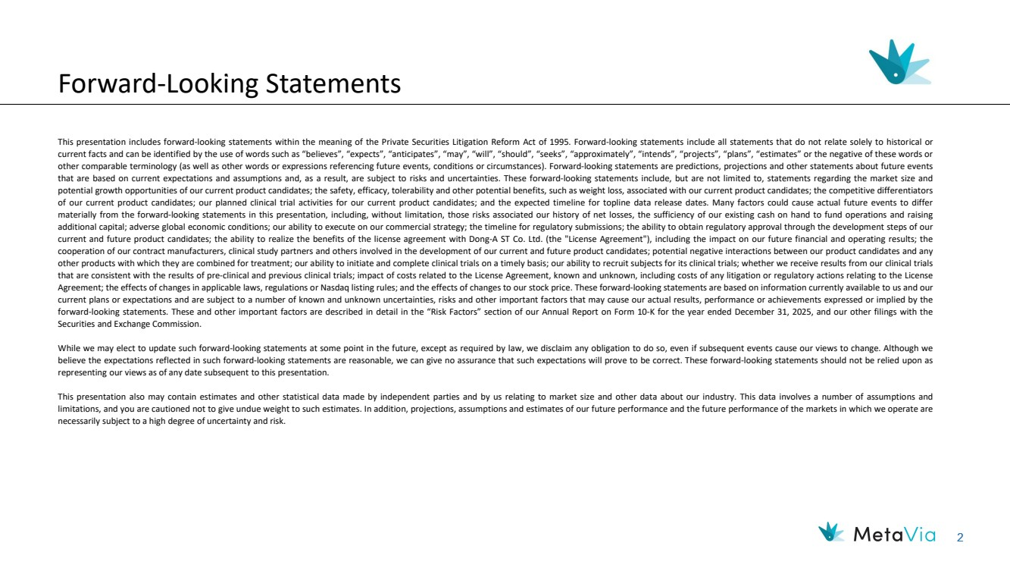 | 2 Forward-Looking Statements This presentation includes forward-looking statements within the meaning of the Private Securities Litigation Reform Act of 1995. Forward-looking statements include all statements that do not relate solely to historical or current facts and can be identified by the use of words such as “believes”, “expects”, “anticipates”, “may”, “will”, “should”, “seeks”, “approximately”, “intends”, “projects”, “plans”, “estimates” or the negative of these words or other comparable terminology (as well as other words or expressions referencing future events, conditions or circumstances). Forward-looking statements are predictions, projections and other statements about future events that are based on current expectations and assumptions and, as a result, are subject to risks and uncertainties. These forward-looking statements include, but are not limited to, statements regarding the market size and potential growth opportunities of our current product candidates; the safety, efficacy, tolerability and other potential benefits, such as weight loss, associated with our current product candidates; the competitive differentiators of our current product candidates; our planned clinical trial activities for our current product candidates; and the expected timeline for topline data release dates. Many factors could cause actual future events to differ materially from the forward-looking statements in this presentation, including, without limitation, those risks associated our history of net losses, the sufficiency of our existing cash on hand to fund operations and raising additional capital; adverse global economic conditions; our ability to execute on our commercial strategy; the timeline for regulatory submissions; the ability to obtain regulatory approval through the development steps of our current and future product candidates; the ability to realize the benefits of the license agreement with Dong-A ST Co. Ltd. (the "License Agreement"), including the impact on our future financial and operating results; the cooperation of our contract manufacturers, clinical study partners and others involved in the development of our current and future product candidates; potential negative interactions between our product candidates and any other products with which they are combined for treatment; our ability to initiate and complete clinical trials on a timely basis; our ability to recruit subjects for its clinical trials; whether we receive results from our clinical trials that are consistent with the results of pre-clinical and previous clinical trials; impact of costs related to the License Agreement, known and unknown, including costs of any litigation or regulatory actions relating to the License Agreement; the effects of changes in applicable laws, regulations or Nasdaq listing rules; and the effects of changes to our stock price. These forward-looking statements are based on information currently available to us and our current plans or expectations and are subject to a number of known and unknown uncertainties, risks and other important factors that may cause our actual results, performance or achievements expressed or implied by the forward-looking statements. These and other important factors are described in detail in the “Risk Factors” section of our Annual Report on Form 10-K for the year ended December 31, 2025, and our other filings with the Securities and Exchange Commission. While we may elect to update such forward-looking statements at some point in the future, except as required by law, we disclaim any obligation to do so, even if subsequent events cause our views to change. Although we believe the expectations reflected in such forward-looking statements are reasonable, we can give no assurance that such expectations will prove to be correct. These forward-looking statements should not be relied upon as representing our views as of any date subsequent to this presentation. This presentation also may contain estimates and other statistical data made by independent parties and by us relating to market size and other data about our industry. This data involves a number of assumptions and limitations, and you are cautioned not to give undue weight to such estimates. In addition, projections, assumptions and estimates of our future performance and the future performance of the markets in which we operate are necessarily subject to a high degree of uncertainty and risk.
 | 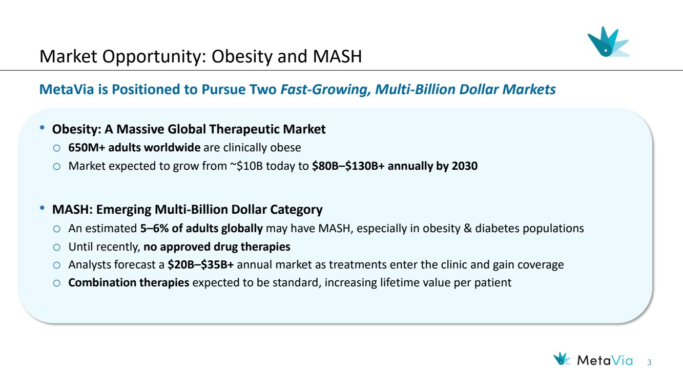 | 3 Market Opportunity: Obesity and MASH MetaVia is Positioned to Pursue Two Fast-Growing, Multi-Billion Dollar Markets • Obesity: A Massive Global Therapeutic Market o 650M+ adults worldwide are clinically obese o Market expected to grow from ~$10B today to $80B–$130B+ annually by 2030 • MASH: Emerging Multi-Billion Dollar Category o An estimated 5–6% of adults globally may have MASH, especially in obesity & diabetes populations o Until recently, no approved drug therapies o Analysts forecast a $20B–$35B+ annual market as treatments enter the clinic and gain coverage o Combination therapies expected to be standard, increasing lifetime value per patient
 | 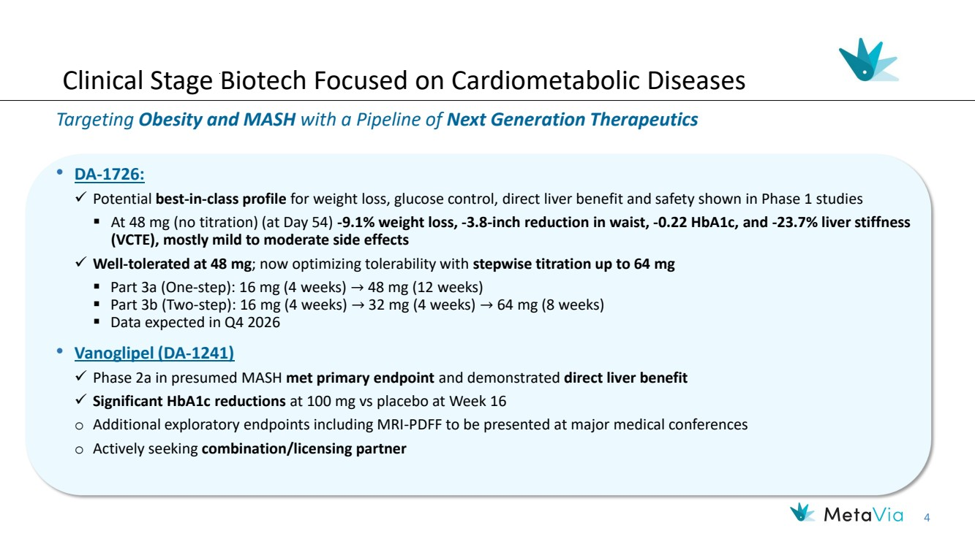 | 4 Clinical Stage Biotech Focused on Cardiometabolic Diseases Targeting Obesity and MASH with a Pipeline of Next Generation Therapeutics • DA-1726: ✓ Potential best-in-class profile for weight loss, glucose control, direct liver benefit and safety shown in Phase 1 studies ▪ At 48 mg (no titration) (at Day 54) -9.1% weight loss, -3.8-inch reduction in waist, -0.22 HbA1c, and -23.7% liver stiffness (VCTE), mostly mild to moderate side effects ✓ Well-tolerated at 48 mg; now optimizing tolerability with stepwise titration up to 64 mg ▪ Part 3a (One-step): 16 mg (4 weeks) → 48 mg (12 weeks) ▪ Part 3b (Two-step): 16 mg (4 weeks) → 32 mg (4 weeks) → 64 mg (8 weeks) ▪ Data expected in Q4 2026 • Vanoglipel (DA-1241) ✓ Phase 2a in presumed MASH met primary endpoint and demonstrated direct liver benefit ✓ Significant HbA1c reductions at 100 mg vs placebo at Week 16 o Additional exploratory endpoints including MRI-PDFF to be presented at major medical conferences o Actively seeking combination/licensing partner
 |  | 5 Strong Leadership Team Executive Management Hyung Heon Kim, Chief Executive Officer Robert Homolka, SVP Clinical Operations Marshall H. Woodworth, Chief Financial Officer Mi-Kyung Kim, Ph.D., RPh, Chief Scientific Officer ▪ 20+ years of experience in M&A, financing and corporate governance ▪ 10+ years of licensing, M&A and compliance with Dong-A Group ▪ Former General Counsel/SVP at Dong-A ST and Dong-A Socio Group ▪ BA Soonghsil University, JD Washington University School of Law ▪ 25+ years in drug discovery research at Dong-A ST ▪ Specialized in diabetes, obesity, MASH, immune-mediated diseases ▪ Ph.D., RPh, College of Pharmacy, Ewha Womans University ▪ 35+ years in pharmaceutical and biotech development ▪ Sr. director of clinical operations in Adiso Therapeutics ▪ Director of clinical operations at Shire/Takeda pharmaceuticals ▪ Director of experimental trial management at AstraZeneca ▪ 35+ years of financial experience ▪ 20+ years working with life science investors and analysts ▪ CFO of Nevakar Inc., Braeburn Pharmaceuticals Inc., Aerocrine AB and Furiex Pharmaceuticals Inc. ▪ BS University of Maryland, MBA Indiana University Chris Fang, MD, Advisor/Consulting Chief Medical Officer ▪ 20+ years of experience in clinical development, R&D and medical affairs ▪ Career focused on obesity, MASH, diabetes and other indications ▪ Held key roles at Eli Lilly, IQVIA, Acer Health and Johnson & Johnson ▪ BA UCLA, Master of Health Science John Hopkins, MD Cornell, MBA Wharton Non-Executive Management
 | 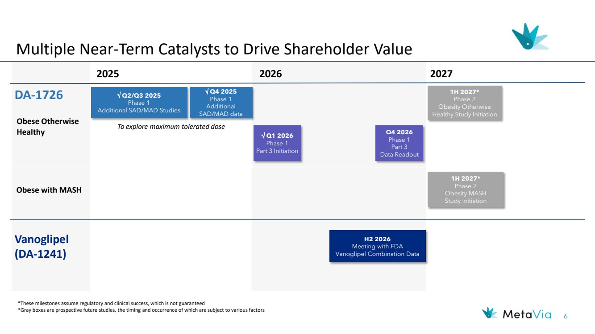 | 6 Multiple Near-Term Catalysts to Drive Shareholder Value 2026 Vanoglipel (DA-1241) H2 2026 Meeting with FDA Vanoglipel Combination Data DA-1726 *These milestones assume regulatory and clinical success, which is not guaranteed *Gray boxes are prospective future studies, the timing and occurrence of which are subject to various factors  Q2/Q3 2025 Phase 1 Additional SAD/MAD Studies  Q4 2025 Phase 1 Additional SAD/MAD data To explore maximum tolerated dose 2025 Obese Otherwise Healthy 2027 Obese with MASH 1H 2027* Phase 2 Obesity MASH Study Initiation  Q1 2026 Phase 1 Part 3 Initiation 1H 2027* Phase 2 Obesity Otherwise Healthy Study Initiation Q4 2026 Phase 1 Part 3 Data Readout
 | 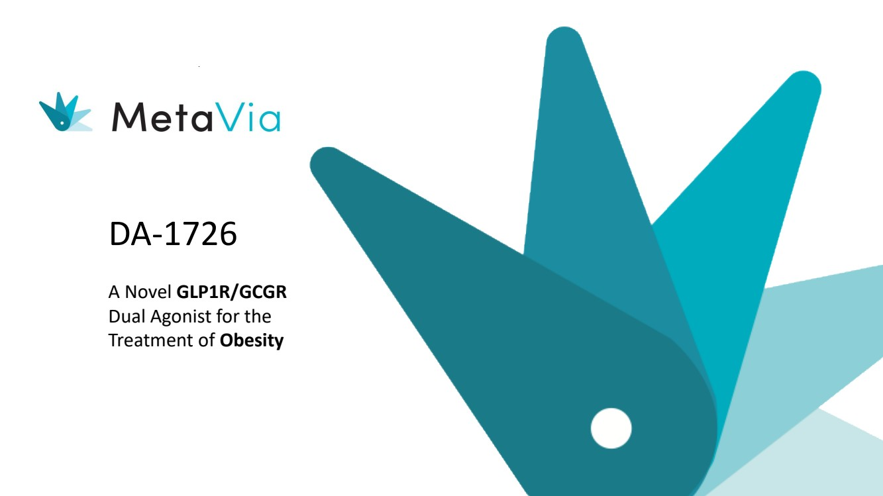 | DA-1726 A Novel GLP1R/GCGR Dual Agonist for the Treatment of Obesity
 | 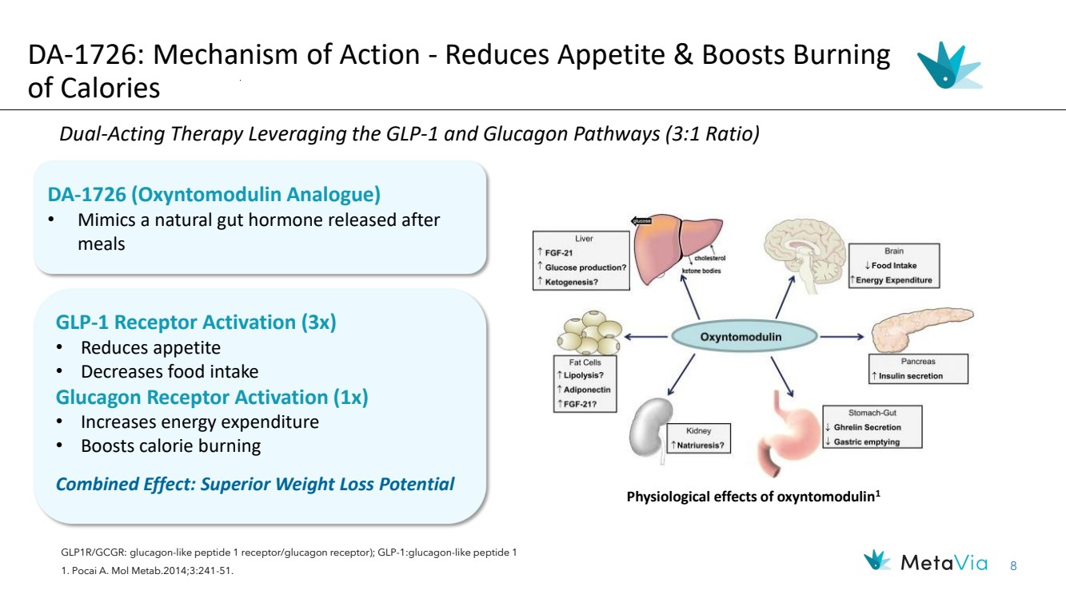 | 8 DA-1726 (Oxyntomodulin Analogue) • Mimics a natural gut hormone released after meals Dual-Acting Therapy Leveraging the GLP-1 and Glucagon Pathways (3:1 Ratio) GLP1R/GCGR: glucagon-like peptide 1 receptor/glucagon receptor); GLP-1:glucagon-like peptide 1 1. Pocai A. Mol Metab.2014;3:241-51. Physiological effects of oxyntomodulin1 DA-1726: Mechanism of Action - Reduces Appetite & Boosts Burning of Calories GLP-1 Receptor Activation (3x) • Reduces appetite • Decreases food intake Glucagon Receptor Activation (1x) • Increases energy expenditure • Boosts calorie burning Combined Effect: Superior Weight Loss Potential
 | 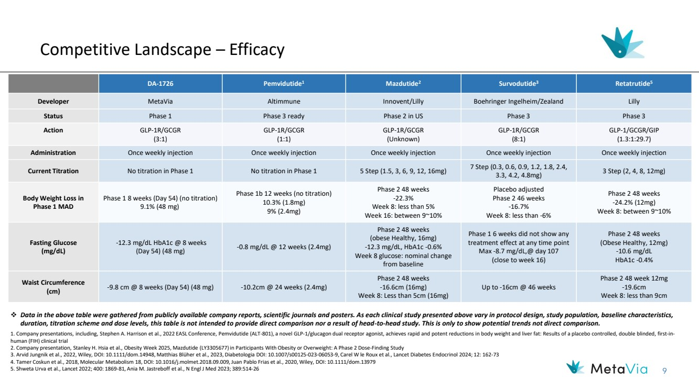 | 9 Competitive Landscape – Efficacy DA-1726 Pemvidutide1 Mazdutide2 Survodutide3 Retatrutide5 Developer MetaVia Altimmune Innovent/Lilly Boehringer Ingelheim/Zealand Lilly Status Phase 1 Phase 3 ready Phase 2 in US Phase 3 Phase 3 Action GLP-1R/GCGR (3:1) GLP-1R/GCGR (1:1) GLP-1R/GCGR (Unknown) GLP-1R/GCGR (8:1) GLP-1/GCGR/GIP (1.3:1:29.7) Administration Once weekly injection Once weekly injection Once weekly injection Once weekly injection Once weekly injection Current Titration No titration in Phase 1 No titration in Phase 1 5 Step (1.5, 3, 6, 9, 12, 16mg) 7 Step (0.3, 0.6, 0.9, 1.2, 1.8, 2.4, 3.3, 4.2, 4.8mg) 3 Step (2, 4, 8, 12mg) Body Weight Loss in Phase 1 MAD Phase 1 8 weeks (Day 54) (no titration) 9.1% (48 mg) Phase 1b 12 weeks (no titration) 10.3% (1.8mg) 9% (2.4mg) Phase 2 48 weeks -22.3% Week 8: less than 5% Week 16: between 9~10% Placebo adjusted Phase 2 46 weeks -16.7% Week 8: less than -6% Phase 2 48 weeks -24.2% (12mg) Week 8: between 9~10% Fasting Glucose (mg/dL) -12.3 mg/dL HbA1c @ 8 weeks (Day 54) (48 mg) -0.8 mg/dL @ 12 weeks (2.4mg) Phase 2 48 weeks (obese Healthy, 16mg) -12.3 mg/dL, HbA1c -0.6% Week 8 glucose: nominal change from baseline Phase 1 6 weeks did not show any treatment effect at any time point Max -8.7 mg/dL,@ day 107 (close to week 16) Phase 2 48 weeks (Obese Healthy, 12mg) -10.6 mg/dL HbA1c -0.4% Waist Circumference (cm) -9.8 cm @ 8 weeks (Day 54) (48 mg) -10.2cm @ 24 weeks (2.4mg) Phase 2 48 weeks -16.6cm (16mg) Week 8: Less than 5cm (16mg) Up to -16cm @ 46 weeks Phase 2 48 week 12mg -19.6cm Week 8: less than 9cm ❖ Data in the above table were gathered from publicly available company reports, scientific journals and posters. As each clinical study presented above vary in protocol design, study population, baseline characteristics, duration, titration scheme and dose levels, this table is not intended to provide direct comparison nor a result of head-to-head study. This is only to show potential trends not direct comparison. 1. Company presentations, including, Stephen A. Harrison et al., 2022 EASL Conference, Pemvidutide (ALT-801), a novel GLP-1/glucagon dual receptor agonist, achieves rapid and potent reductions in body weight and liver fat: Results of a placebo controlled, double blinded, first-in-human (FIH) clinical trial 2. Company presentation, Stanley H. Hsia et al., Obesity Week 2025, Mazdutide (LY3305677) in Participants With Obesity or Overweight: A Phase 2 Dose-Finding Study 3. Arvid Jungnik et al., 2022, Wiley, DOI: 10.1111/dom.14948, Matthias Blüher et al., 2023, Diabetologia DOI: 10.1007/s00125-023-06053-9, Carel W le Roux et al., Lancet Diabetes Endocrinol 2024; 12: 162-73 4. Tamer Coskun et al., 2018, Molecular Metabolism 18, DOI: 10.1016/j.molmet.2018.09.009, Juan Pablo Frias et al., 2020, Wiley, DOI: 10.1111/dom.13979 5. Shweta Urva et al., Lancet 2022; 400: 1869-81, Ania M. Jastreboff et al., N Engl J Med 2023; 389:514-26
 | 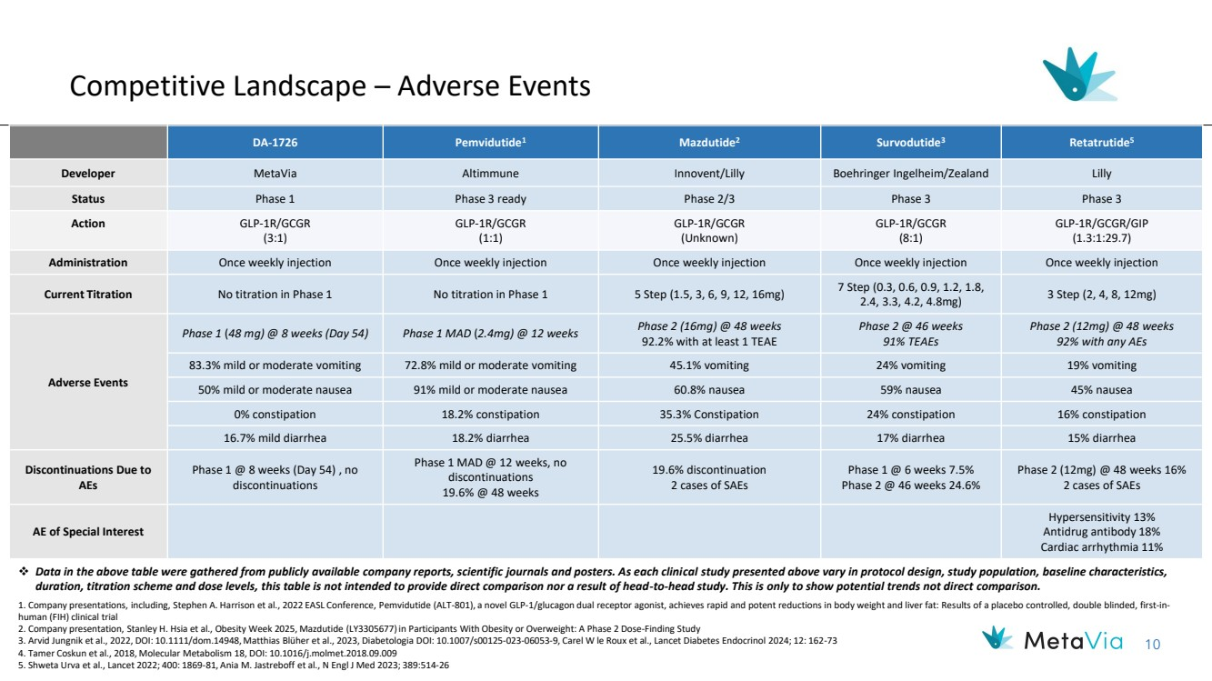 | 10 Competitive Landscape – Adverse Events DA-1726 Pemvidutide1 Mazdutide2 Survodutide3 Retatrutide5 Developer MetaVia Altimmune Innovent/Lilly Boehringer Ingelheim/Zealand Lilly Status Phase 1 Phase 3 ready Phase 2/3 Phase 3 Phase 3 Action GLP-1R/GCGR (3:1) GLP-1R/GCGR (1:1) GLP-1R/GCGR (Unknown) GLP-1R/GCGR (8:1) GLP-1R/GCGR/GIP (1.3:1:29.7) Administration Once weekly injection Once weekly injection Once weekly injection Once weekly injection Once weekly injection Current Titration No titration in Phase 1 No titration in Phase 1 5 Step (1.5, 3, 6, 9, 12, 16mg) 7 Step (0.3, 0.6, 0.9, 1.2, 1.8, 2.4, 3.3, 4.2, 4.8mg) 3 Step (2, 4, 8, 12mg) Adverse Events Phase 1 (48 mg) @ 8 weeks (Day 54) Phase 1 MAD (2.4mg) @ 12 weeks Phase 2 (16mg) @ 48 weeks 92.2% with at least 1 TEAE Phase 2 @ 46 weeks 91% TEAEs Phase 2 (12mg) @ 48 weeks 92% with any AEs 83.3% mild or moderate vomiting 72.8% mild or moderate vomiting 45.1% vomiting 24% vomiting 19% vomiting 50% mild or moderate nausea 91% mild or moderate nausea 60.8% nausea 59% nausea 45% nausea 0% constipation 18.2% constipation 35.3% Constipation 24% constipation 16% constipation 16.7% mild diarrhea 18.2% diarrhea 25.5% diarrhea 17% diarrhea 15% diarrhea Discontinuations Due to AEs Phase 1 @ 8 weeks (Day 54) , no discontinuations Phase 1 MAD @ 12 weeks, no discontinuations 19.6% @ 48 weeks 19.6% discontinuation 2 cases of SAEs Phase 1 @ 6 weeks 7.5% Phase 2 @ 46 weeks 24.6% Phase 2 (12mg) @ 48 weeks 16% 2 cases of SAEs AE of Special Interest Hypersensitivity 13% Antidrug antibody 18% Cardiac arrhythmia 11% ❖ Data in the above table were gathered from publicly available company reports, scientific journals and posters. As each clinical study presented above vary in protocol design, study population, baseline characteristics, duration, titration scheme and dose levels, this table is not intended to provide direct comparison nor a result of head-to-head study. This is only to show potential trends not direct comparison. 1. Company presentations, including, Stephen A. Harrison et al., 2022 EASL Conference, Pemvidutide (ALT-801), a novel GLP-1/glucagon dual receptor agonist, achieves rapid and potent reductions in body weight and liver fat: Results of a placebo controlled, double blinded, first-in-human (FIH) clinical trial 2. Company presentation, Stanley H. Hsia et al., Obesity Week 2025, Mazdutide (LY3305677) in Participants With Obesity or Overweight: A Phase 2 Dose-Finding Study 3. Arvid Jungnik et al., 2022, DOI: 10.1111/dom.14948, Matthias Blüher et al., 2023, Diabetologia DOI: 10.1007/s00125-023-06053-9, Carel W le Roux et al., Lancet Diabetes Endocrinol 2024; 12: 162-73 4. Tamer Coskun et al., 2018, Molecular Metabolism 18, DOI: 10.1016/j.molmet.2018.09.009 5. Shweta Urva et al., Lancet 2022; 400: 1869-81, Ania M. Jastreboff et al., N Engl J Med 2023; 389:514-26
 | 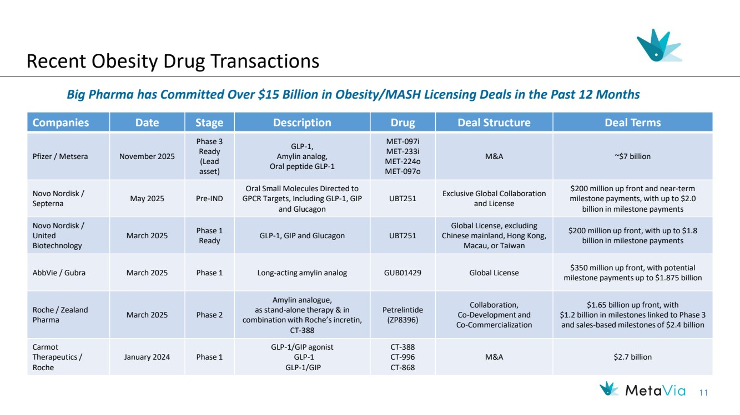 | 11 Recent Obesity Drug Transactions Companies Date Stage Description Drug Deal Structure Deal Terms Pfizer / Metsera November 2025 Phase 3 Ready (Lead asset) GLP-1, Amylin analog, Oral peptide GLP-1 MET-097i MET-233i MET-224o MET-097o M&A ~$7 billion Novo Nordisk / Septerna May 2025 Pre-IND Oral Small Molecules Directed to GPCR Targets, Including GLP-1, GIP and Glucagon UBT251 Exclusive Global Collaboration and License $200 million up front and near-term milestone payments, with up to $2.0 billion in milestone payments Novo Nordisk / United Biotechnology March 2025 Phase 1 Ready GLP-1, GIP and Glucagon UBT251 Global License, excluding Chinese mainland, Hong Kong, Macau, or Taiwan $200 million up front, with up to $1.8 billion in milestone payments AbbVie / Gubra March 2025 Phase 1 Long-acting amylin analog GUB01429 Global License $350 million up front, with potential milestone payments up to $1.875 billion Roche / Zealand Pharma March 2025 Phase 2 Amylin analogue, as stand-alone therapy & in combination with Roche’s incretin, CT-388 Petrelintide (ZP8396) Collaboration, Co-Development and Co-Commercialization $1.65 billion up front, with $1.2 billion in milestones linked to Phase 3 and sales-based milestones of $2.4 billion Carmot Therapeutics / Roche January 2024 Phase 1 GLP-1/GIP agonist GLP-1 GLP-1/GIP CT-388 CT-996 CT-868 M&A $2.7 billion Big Pharma has Committed Over $15 Billion in Obesity/MASH Licensing Deals in the Past 12 Months
 | 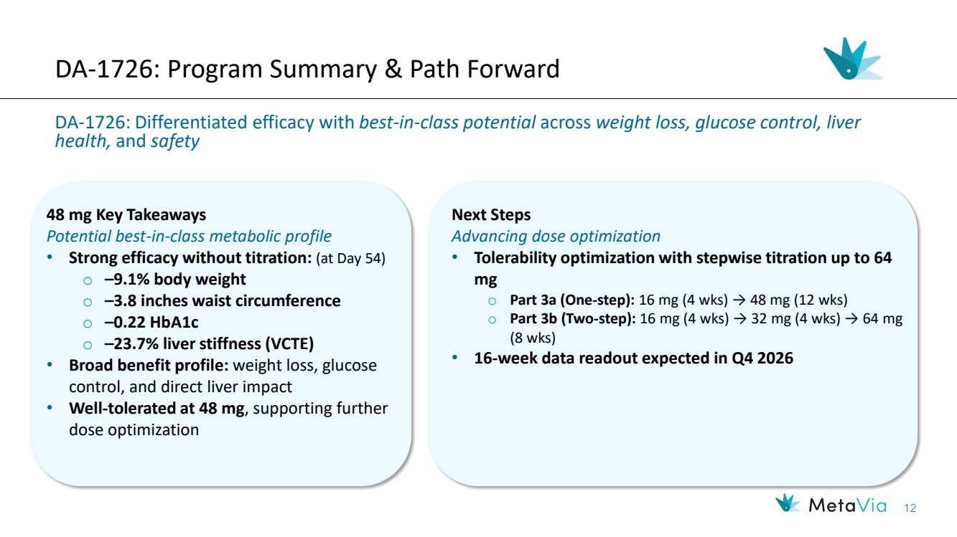 | 12 DA-1726: Program Summary & Path Forward DA-1726: Differentiated efficacy with best-in-class potential across weight loss, glucose control, liver health, and safety 48 mg Key Takeaways Potential best-in-class metabolic profile • Strong efficacy without titration: (at Day 54) o –9.1% body weight o –3.8 inches waist circumference o –0.22 HbA1c o –23.7% liver stiffness (VCTE) • Broad benefit profile: weight loss, glucose control, and direct liver impact • Well-tolerated at 48 mg, supporting further dose optimization Next Steps Advancing dose optimization • Tolerability optimization with stepwise titration up to 64 mg o Part 3a (One-step): 16 mg (4 wks) → 48 mg (12 wks) o Part 3b (Two-step): 16 mg (4 wks) → 32 mg (4 wks) → 64 mg (8 wks) • 16-week data readout expected in Q4 2026
 | 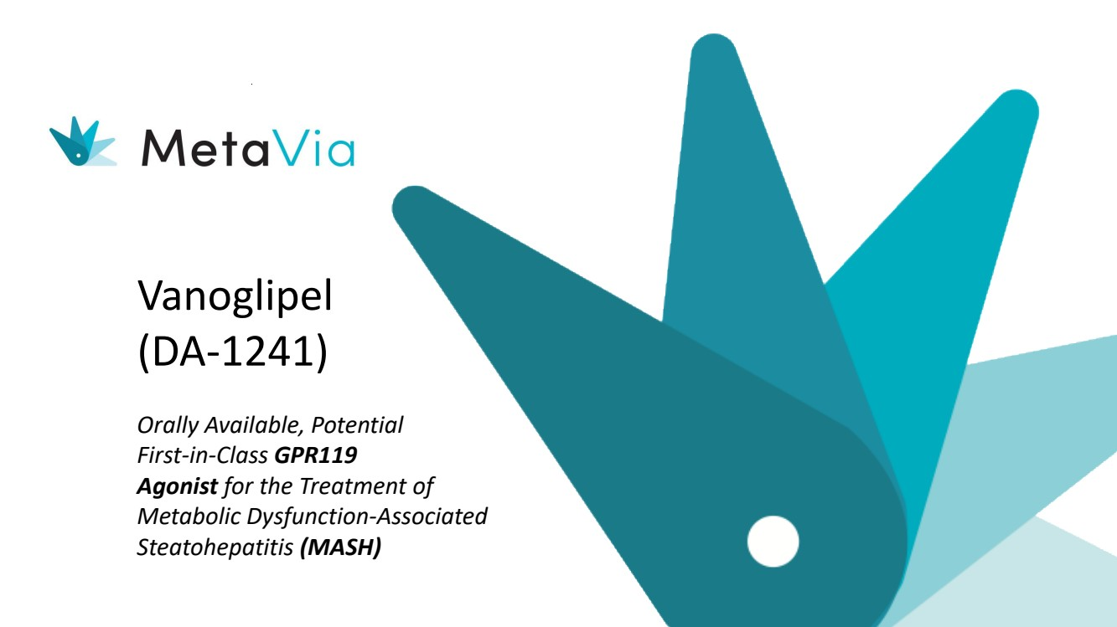 | Vanoglipel (DA-1241) Orally Available, Potential First-in-Class GPR119 Agonist for the Treatment of Metabolic Dysfunction-Associated Steatohepatitis (MASH)
 | 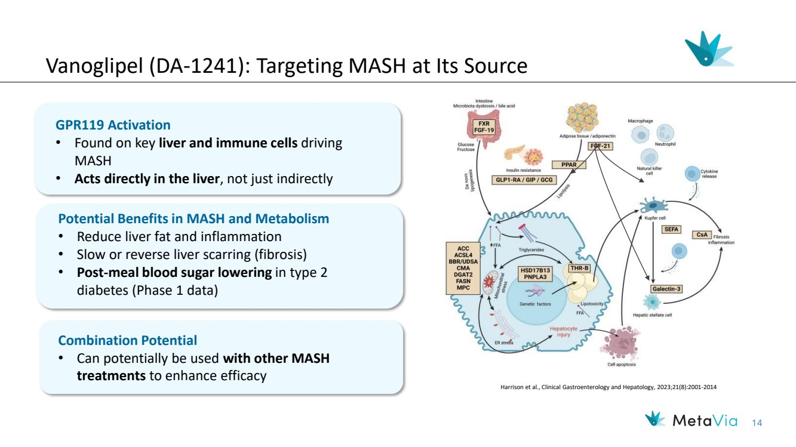 | 14 Vanoglipel (DA-1241): Targeting MASH at Its Source Harrison et al., Clinical Gastroenterology and Hepatology, 2023;21(8):2001-2014 GPR119 Activation • Found on key liver and immune cells driving MASH • Acts directly in the liver, not just indirectly Potential Benefits in MASH and Metabolism • Reduce liver fat and inflammation • Slow or reverse liver scarring (fibrosis) • Post-meal blood sugar lowering in type 2 diabetes (Phase 1 data) Combination Potential • Can potentially be used with other MASH treatments to enhance efficacy
 | 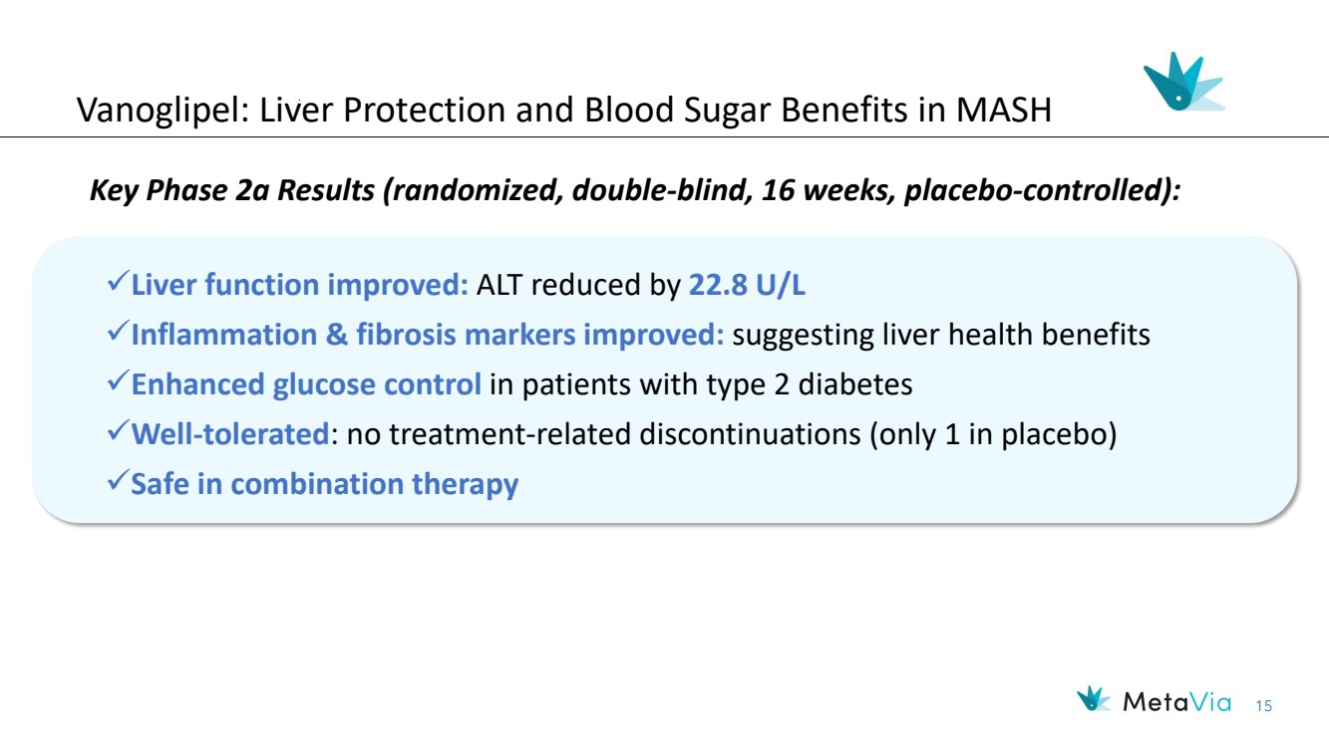 | 15 Vanoglipel: Liver Protection and Blood Sugar Benefits in MASH Key Phase 2a Results (randomized, double-blind, 16 weeks, placebo-controlled): ✓Liver function improved: ALT reduced by 22.8 U/L ✓Inflammation & fibrosis markers improved: suggesting liver health benefits ✓Enhanced glucose control in patients with type 2 diabetes ✓Well-tolerated: no treatment-related discontinuations (only 1 in placebo) ✓Safe in combination therapy
 | 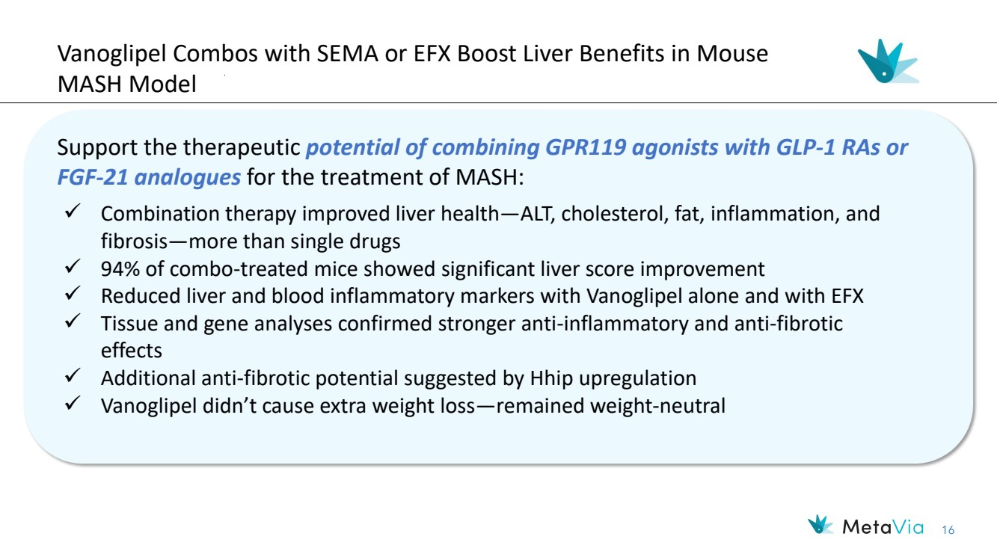 | 16 Vanoglipel Combos with SEMA or EFX Boost Liver Benefits in Mouse MASH Model Support the therapeutic potential of combining GPR119 agonists with GLP-1 RAs or FGF-21 analogues for the treatment of MASH: ✓ Combination therapy improved liver health—ALT, cholesterol, fat, inflammation, and fibrosis—more than single drugs ✓ 94% of combo-treated mice showed significant liver score improvement ✓ Reduced liver and blood inflammatory markers with Vanoglipel alone and with EFX ✓ Tissue and gene analyses confirmed stronger anti-inflammatory and anti-fibrotic effects ✓ Additional anti-fibrotic potential suggested by Hhip upregulation ✓ Vanoglipel didn’t cause extra weight loss—remained weight-neutral
 | 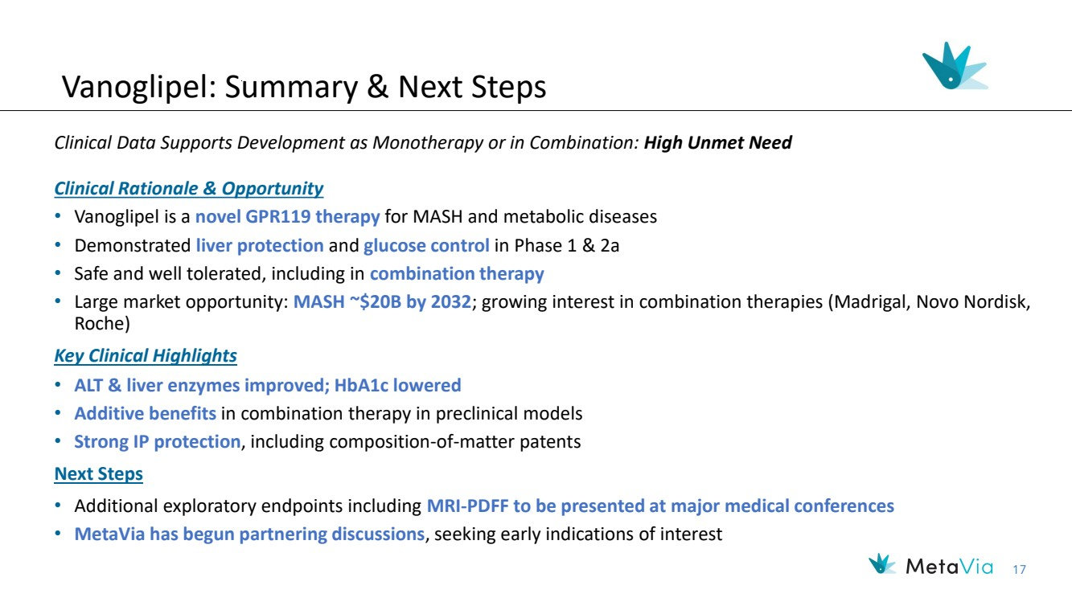 | 17 Vanoglipel: Summary & Next Steps Clinical Rationale & Opportunity • Vanoglipel is a novel GPR119 therapy for MASH and metabolic diseases • Demonstrated liver protection and glucose control in Phase 1 & 2a • Safe and well tolerated, including in combination therapy • Large market opportunity: MASH ~$20B by 2032; growing interest in combination therapies (Madrigal, Novo Nordisk, Roche) Key Clinical Highlights • ALT & liver enzymes improved; HbA1c lowered • Additive benefits in combination therapy in preclinical models • Strong IP protection, including composition-of-matter patents Next Steps • Additional exploratory endpoints including MRI-PDFF to be presented at major medical conferences • MetaVia has begun partnering discussions, seeking early indications of interest Clinical Data Supports Development as Monotherapy or in Combination: High Unmet Need
 |  | Financials and Capitalization
 | 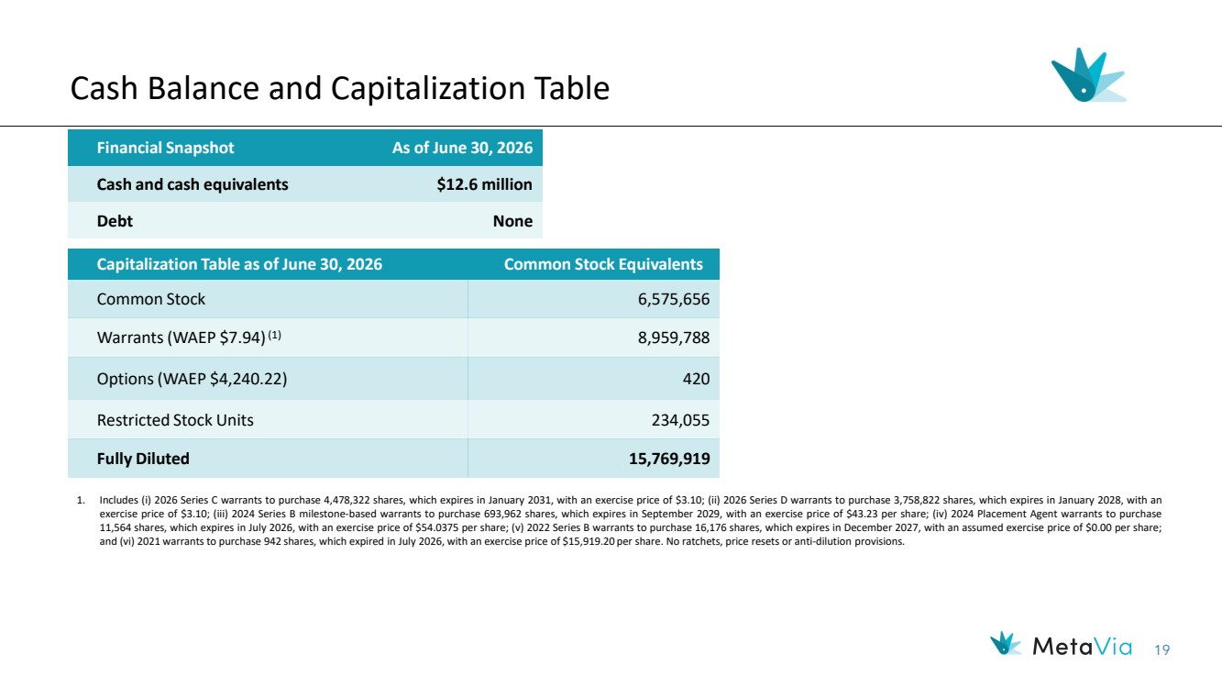 | 19 Cash Balance and Capitalization Table Financial Snapshot As of June 30, 2026 Cash and cash equivalents $12.6 million Debt None Capitalization Table as of June 30, 2026 Common Stock Equivalents Common Stock 6,575,656 Warrants (WAEP $7.94)(1) 8,959,788 Options (WAEP $4,240.22) 420 Restricted Stock Units 234,055 Fully Diluted 15,769,919 1. Includes (i) 2026 Series C warrants to purchase 4,478,322 shares, which expires in January 2031, with an exercise price of $3.10; (ii) 2026 Series D warrants to purchase 3,758,822 shares, which expires in January 2028, with an exercise price of $3.10; (iii) 2024 Series B milestone-based warrants to purchase 693,962 shares, which expires in September 2029, with an exercise price of $43.23 per share; (iv) 2024 Placement Agent warrants to purchase 11,564 shares, which expires in July 2026, with an exercise price of $54.0375 per share; (v) 2022 Series B warrants to purchase 16,176 shares, which expires in December 2027, with an assumed exercise price of $0.00 per share; and (vi) 2021 warrants to purchase 942 shares, which expired in July 2026, with an exercise price of $15,919.20 per share. No ratchets, price resets or anti-dilution provisions.
 | 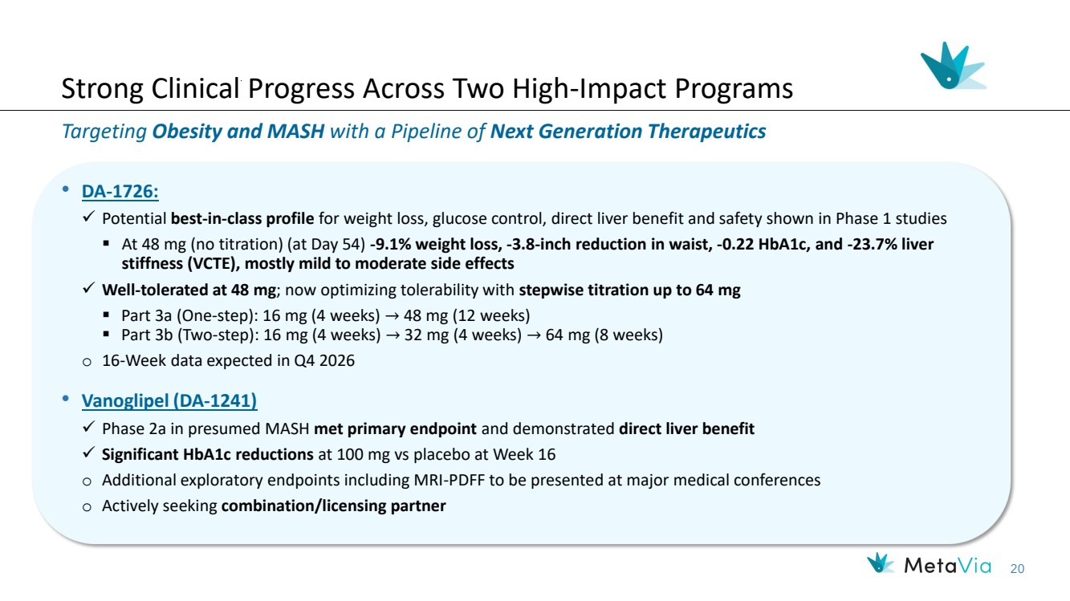 | 20 Strong Clinical Progress Across Two High-Impact Programs Targeting Obesity and MASH with a Pipeline of Next Generation Therapeutics • DA-1726: ✓ Potential best-in-class profile for weight loss, glucose control, direct liver benefit and safety shown in Phase 1 studies ▪ At 48 mg (no titration) (at Day 54) -9.1% weight loss, -3.8-inch reduction in waist, -0.22 HbA1c, and -23.7% liver stiffness (VCTE), mostly mild to moderate side effects ✓ Well-tolerated at 48 mg; now optimizing tolerability with stepwise titration up to 64 mg ▪ Part 3a (One-step): 16 mg (4 weeks) → 48 mg (12 weeks) ▪ Part 3b (Two-step): 16 mg (4 weeks) → 32 mg (4 weeks) → 64 mg (8 weeks) o 16-Week data expected in Q4 2026 • Vanoglipel (DA-1241) ✓ Phase 2a in presumed MASH met primary endpoint and demonstrated direct liver benefit ✓ Significant HbA1c reductions at 100 mg vs placebo at Week 16 o Additional exploratory endpoints including MRI-PDFF to be presented at major medical conferences o Actively seeking combination/licensing partner
 | 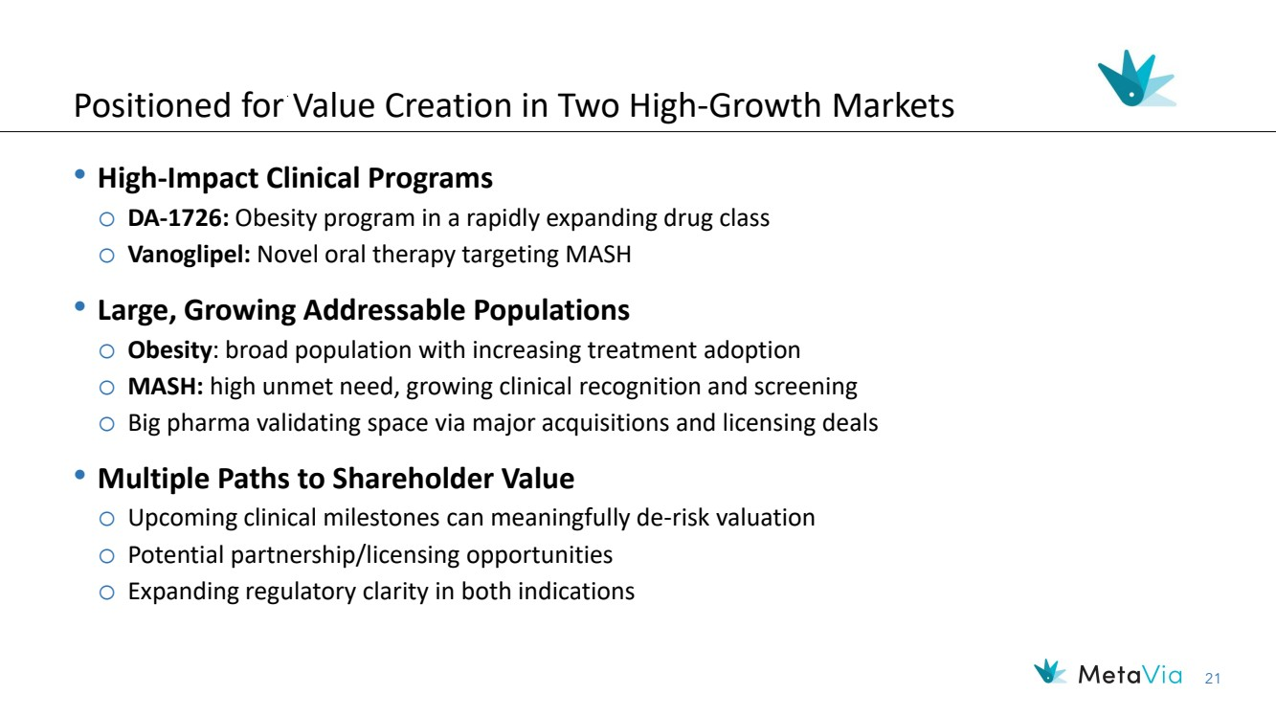 | 21 Positioned for Value Creation in Two High-Growth Markets • High-Impact Clinical Programs o DA-1726: Obesity program in a rapidly expanding drug class o Vanoglipel: Novel oral therapy targeting MASH • Large, Growing Addressable Populations o Obesity: broad population with increasing treatment adoption o MASH: high unmet need, growing clinical recognition and screening o Big pharma validating space via major acquisitions and licensing deals • Multiple Paths to Shareholder Value o Upcoming clinical milestones can meaningfully de-risk valuation o Potential partnership/licensing opportunities o Expanding regulatory clarity in both indications
 |  | Thank You! Investor Contacts: Rx Communications Group Michael Miller +1 917.633.6086 mmiller@rxir.com MetaVia Marshall Woodworth +1 919.749.8748 marshall.woodworth@metaviatx.com
 |  | Appendix
DA-1726 A Novel GLP1R/GCGR Dual Agonist for the Treatment of Obesity
 | 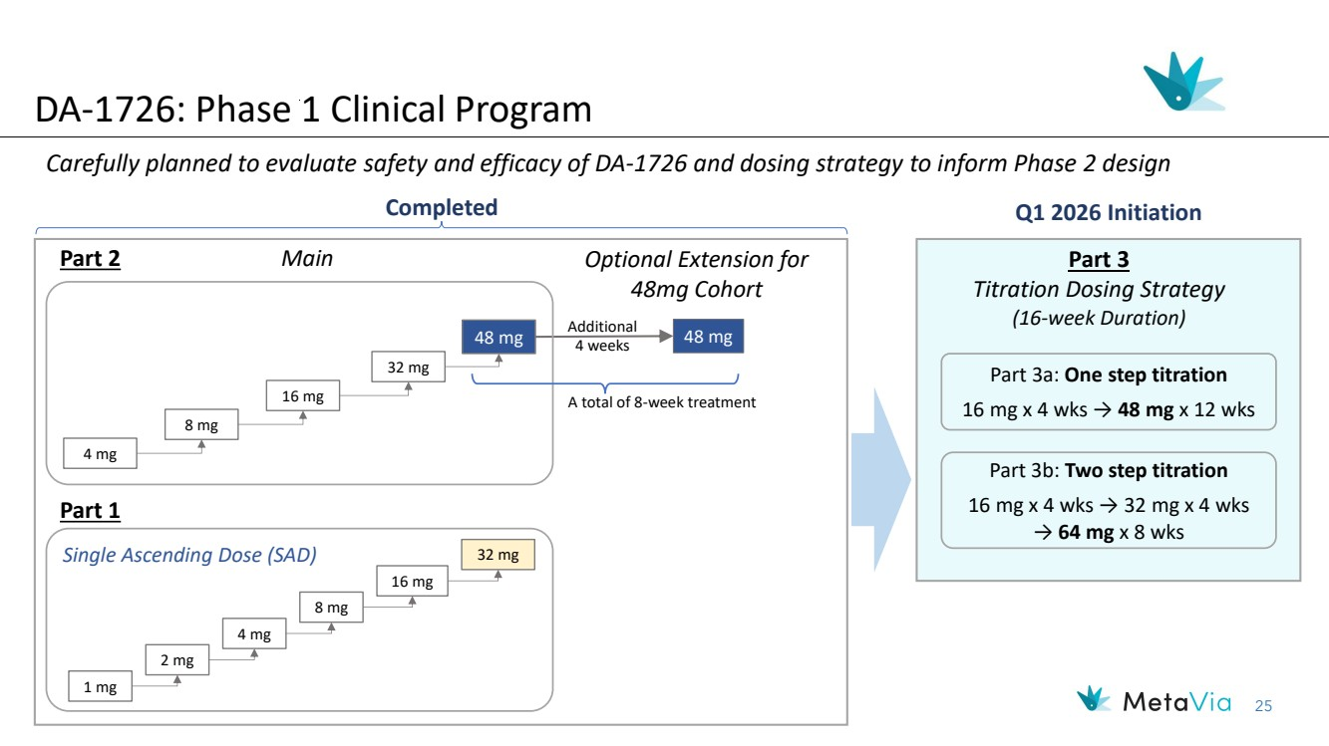 | 25 DA-1726: Phase 1 Clinical Program Carefully planned to evaluate safety and efficacy of DA-1726 and dosing strategy to inform Phase 2 design Main Optional Extension for 48mg Cohort Part 3 Titration Dosing Strategy (16-week Duration) 48 mg 48 mg Q1 2026 Initiation Additional 4 weeks 16 mg 4 mg 8 mg Single Ascending Dose (SAD) 32 mg 16 mg 1 mg 2 mg 4 mg 8 mg Completed 32 mg A total of 8-week treatment Part 2 Part 1 Part 3a: One step titration 16 mg x 4 wks → 48 mg x 12 wks Part 3b: Two step titration 16 mg x 4 wks → 32 mg x 4 wks → 64 mg x 8 wks
 | 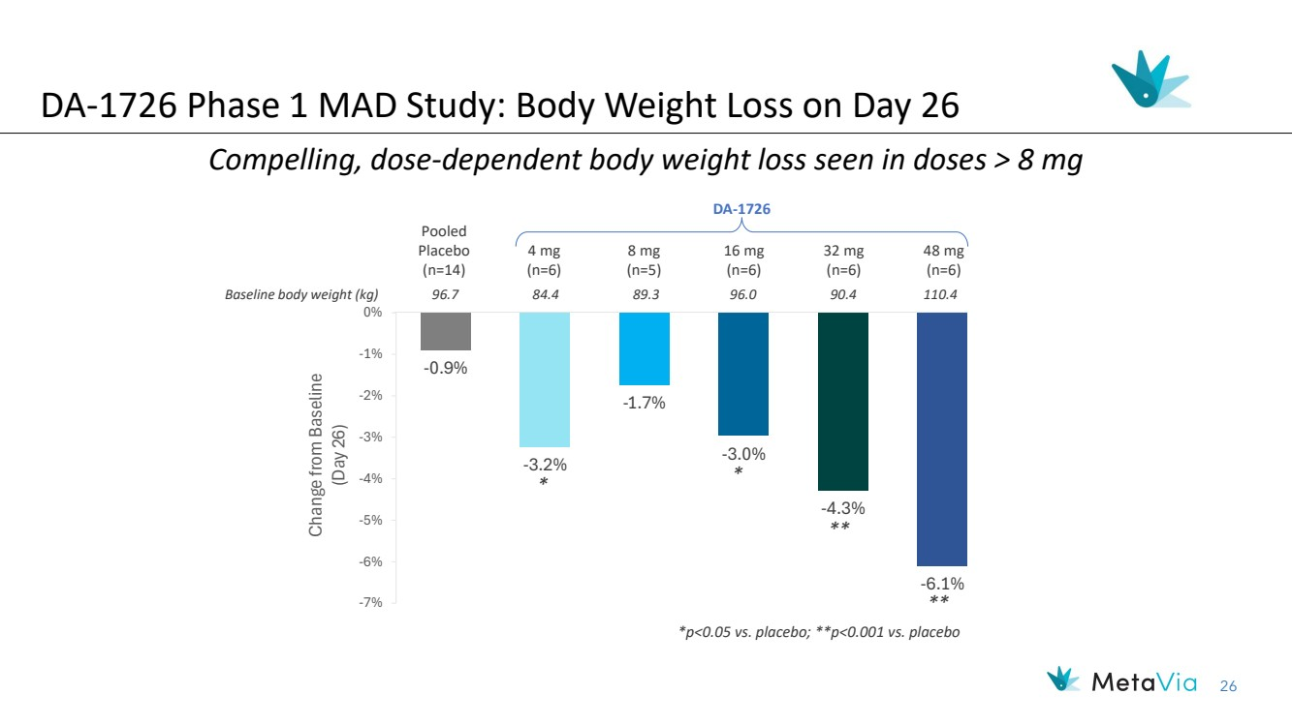 | 26 -0.9% -3.2% -1.7% -3.0% -4.3% -6.1% -7% -6% -5% -4% -3% -2% -1% 0% Change from Baseline (Day 26) Baseline body weight (kg) 96.7 84.4 89.3 96.0 90.4 110.4 Compelling, dose-dependent body weight loss seen in doses > 8 mg Pooled Placebo (n=14) 4 mg (n=6) 8 mg (n=5) 16 mg (n=6) 32 mg (n=6) 48 mg (n=6) DA-1726 * * ** ** DA-1726 Phase 1 MAD Study: Body Weight Loss on Day 26 *p<0.05 vs. placebo; **p<0.001 vs. placebo
 | 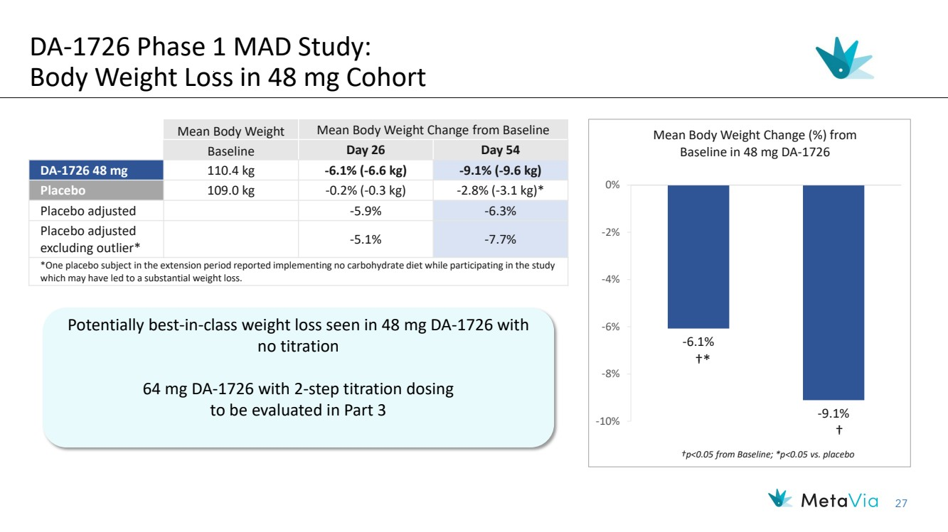 | 27 Mean Body Weight Mean Body Weight Change from Baseline Baseline Day 26 Day 54 DA-1726 48 mg 110.4 kg -6.1% (-6.6 kg) -9.1% (-9.6 kg) Placebo 109.0 kg -0.2% (-0.3 kg) -2.8% (-3.1 kg)* Placebo adjusted -5.9% -6.3% Placebo adjusted excluding outlier* -5.1% -7.7% *One placebo subject in the extension period reported implementing no carbohydrate diet while participating in the study which may have led to a substantial weight loss. Potentially best-in-class weight loss seen in 48 mg DA-1726 with no titration 64 mg DA-1726 with 2-step titration dosing to be evaluated in Part 3 DA-1726 Phase 1 MAD Study: Body Weight Loss in 48 mg Cohort -6.1% -9.1% -10% -8% -6% -4% -2% 0% Mean Body Weight Change (%) from Baseline in 48 mg DA-1726 †p<0.05 from Baseline; *p<0.05 vs. placebo †* †
 | 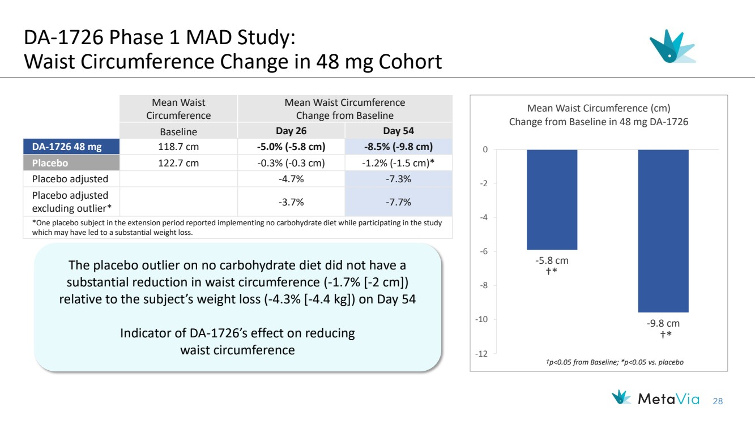 | 28 -5.8 cm -9.8 cm -12 -10 -8 -6 -4 -2 0 Mean Waist Circumference (cm) Change from Baseline in 48 mg DA-1726 †* †* †p<0.05 from Baseline; *p<0.05 vs. placebo Mean Waist Circumference Mean Waist Circumference Change from Baseline Baseline Day 26 Day 54 DA-1726 48 mg 118.7 cm -5.0% (-5.8 cm) -8.5% (-9.8 cm) Placebo 122.7 cm -0.3% (-0.3 cm) -1.2% (-1.5 cm)* Placebo adjusted -4.7% -7.3% Placebo adjusted excluding outlier* -3.7% -7.7% *One placebo subject in the extension period reported implementing no carbohydrate diet while participating in the study which may have led to a substantial weight loss. DA-1726 Phase 1 MAD Study: Waist Circumference Change in 48 mg Cohort The placebo outlier on no carbohydrate diet did not have a substantial reduction in waist circumference (-1.7% [-2 cm]) relative to the subject’s weight loss (-4.3% [-4.4 kg]) on Day 54 Indicator of DA-1726’s effect on reducing waist circumference
 | 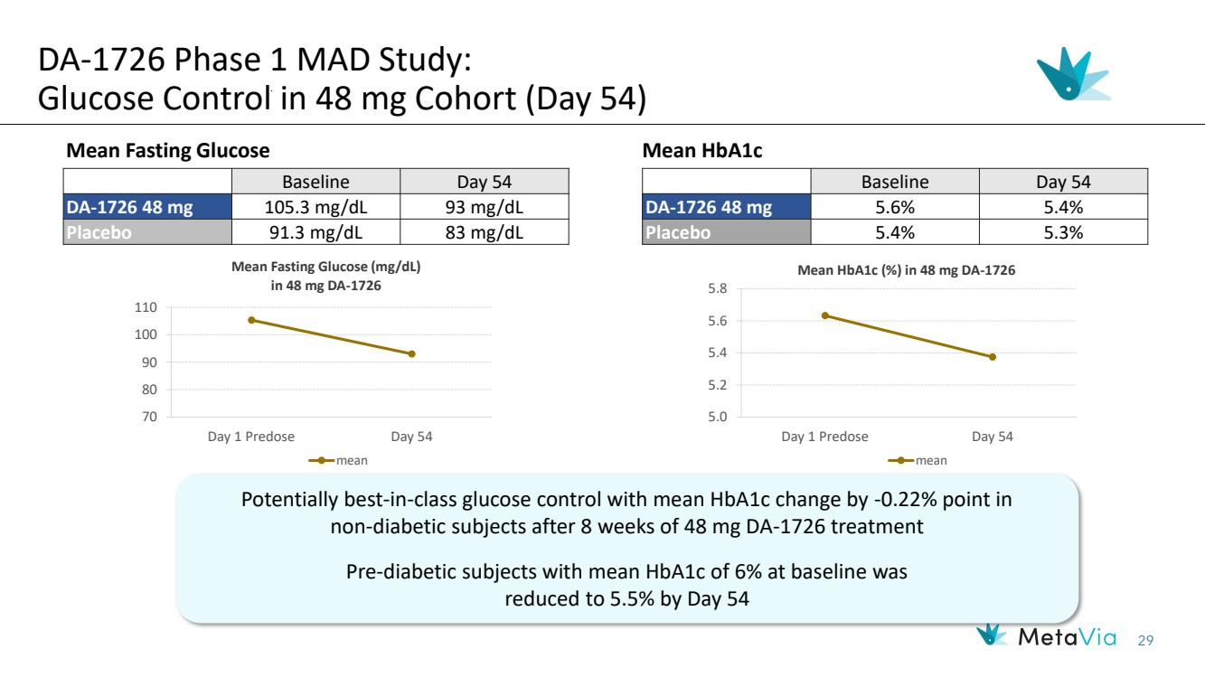 | 29 Baseline Day 54 DA-1726 48 mg 105.3 mg/dL 93 mg/dL Placebo 91.3 mg/dL 83 mg/dL 70 80 90 100 110 Day 1 Predose Day 54 Mean Fasting Glucose (mg/dL) in 48 mg DA-1726 mean Mean Fasting Glucose Baseline Day 54 DA-1726 48 mg 5.6% 5.4% Placebo 5.4% 5.3% Mean HbA1c 5.0 5.2 5.4 5.6 5.8 Day 1 Predose Day 54 Mean HbA1c (%) in 48 mg DA-1726 mean DA-1726 Phase 1 MAD Study: Glucose Control in 48 mg Cohort (Day 54) Potentially best-in-class glucose control with mean HbA1c change by -0.22% point in non-diabetic subjects after 8 weeks of 48 mg DA-1726 treatment Pre-diabetic subjects with mean HbA1c of 6% at baseline was reduced to 5.5% by Day 54
 | 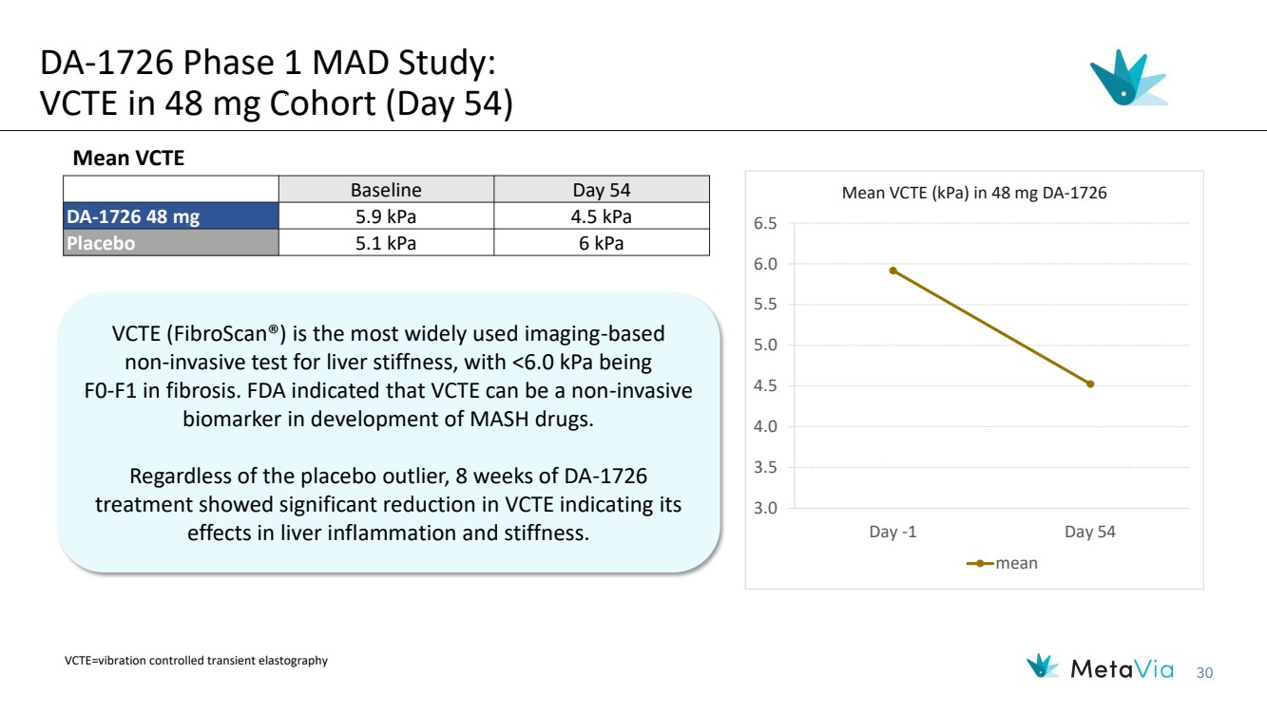 | 30 Baseline Day 54 DA-1726 48 mg 5.9 kPa 4.5 kPa Placebo 5.1 kPa 6 kPa 3.0 3.5 4.0 4.5 5.0 5.5 6.0 6.5 Day -1 Day 54 Mean VCTE (kPa) in 48 mg DA-1726 mean DA-1726 Phase 1 MAD Study: VCTE in 48 mg Cohort (Day 54) Mean VCTE VCTE=vibration controlled transient elastography VCTE (FibroScan®) is the most widely used imaging-based non-invasive test for liver stiffness, with <6.0 kPa being F0-F1 in fibrosis. FDA indicated that VCTE can be a non-invasive biomarker in development of MASH drugs. Regardless of the placebo outlier, 8 weeks of DA-1726 treatment showed significant reduction in VCTE indicating its effects in liver inflammation and stiffness.
 | 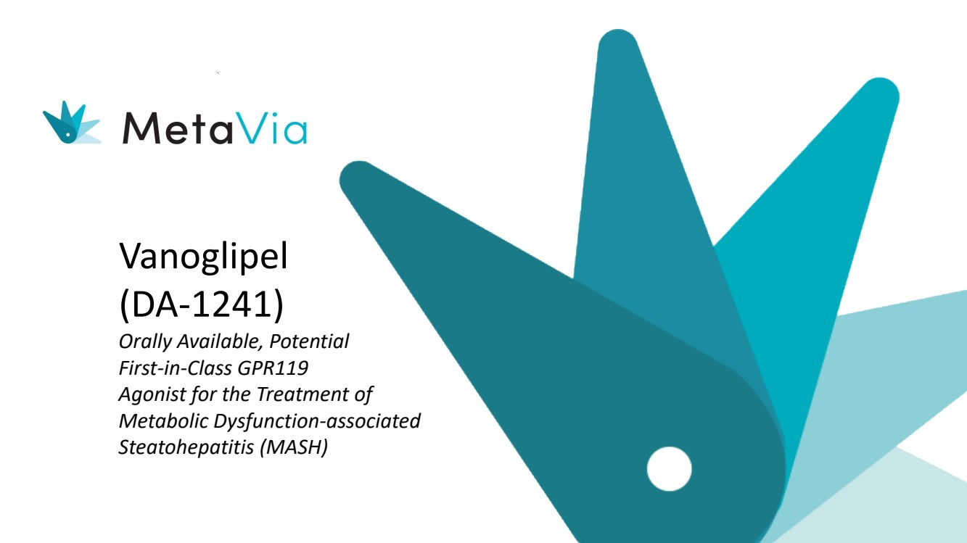 | Vanoglipel (DA-1241) Orally Available, Potential First-in-Class GPR119 Agonist for the Treatment of Metabolic Dysfunction-associated Steatohepatitis (MASH)
 | 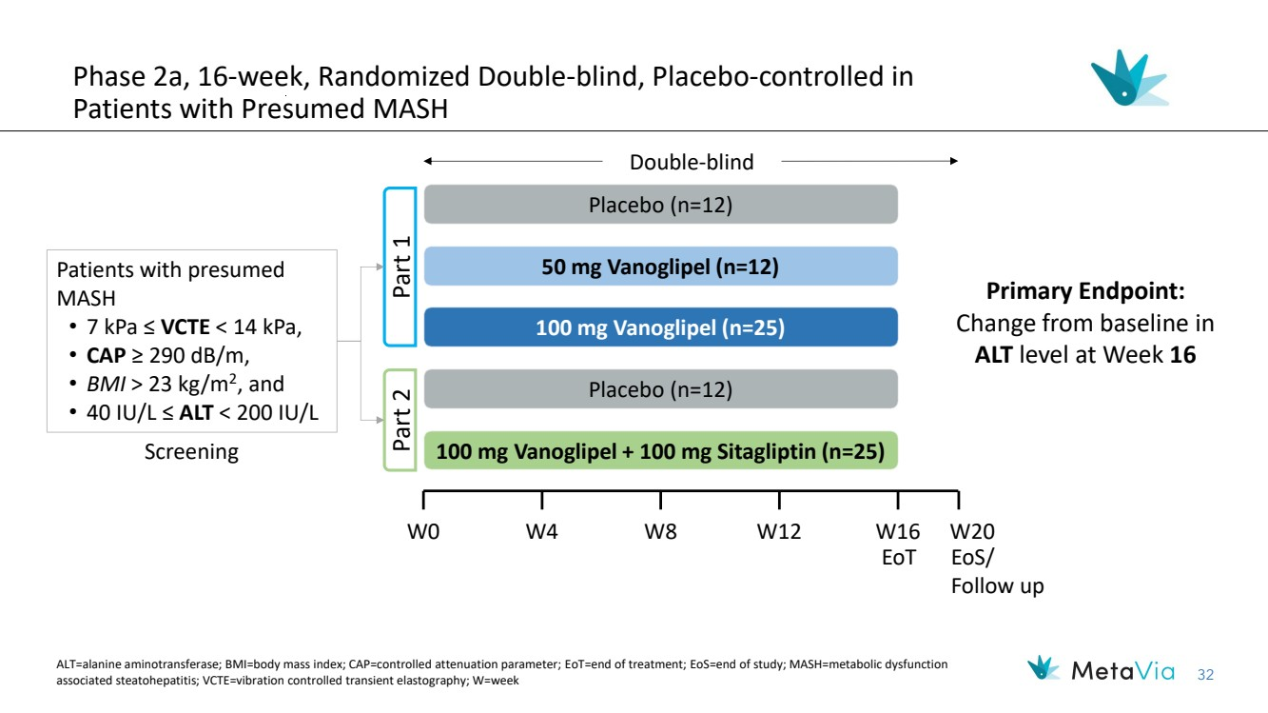 | 32 Phase 2a, 16-week, Randomized Double-blind, Placebo-controlled in Patients with Presumed MASH Primary Endpoint: Change from baseline in ALT level at Week 16 50 mg Vanoglipel (n=12) 100 mg Vanoglipel (n=25) Placebo (n=12) Part 1 Placebo (n=12) Part 2 100 mg Vanoglipel + 100 mg Sitagliptin (n=25) Patients with presumed MASH • 7 kPa ≤ VCTE < 14 kPa, • CAP ≥ 290 dB/m, • BMI > 23 kg/m2 , and • 40 IU/L ≤ ALT < 200 IU/L Double-blind Screening W0 W4 W8 W12 W16 W20 EoT EoS/ Follow up ALT=alanine aminotransferase; BMI=body mass index; CAP=controlled attenuation parameter; EoT=end of treatment; EoS=end of study; MASH=metabolic dysfunction associated steatohepatitis; VCTE=vibration controlled transient elastography; W=week
 | 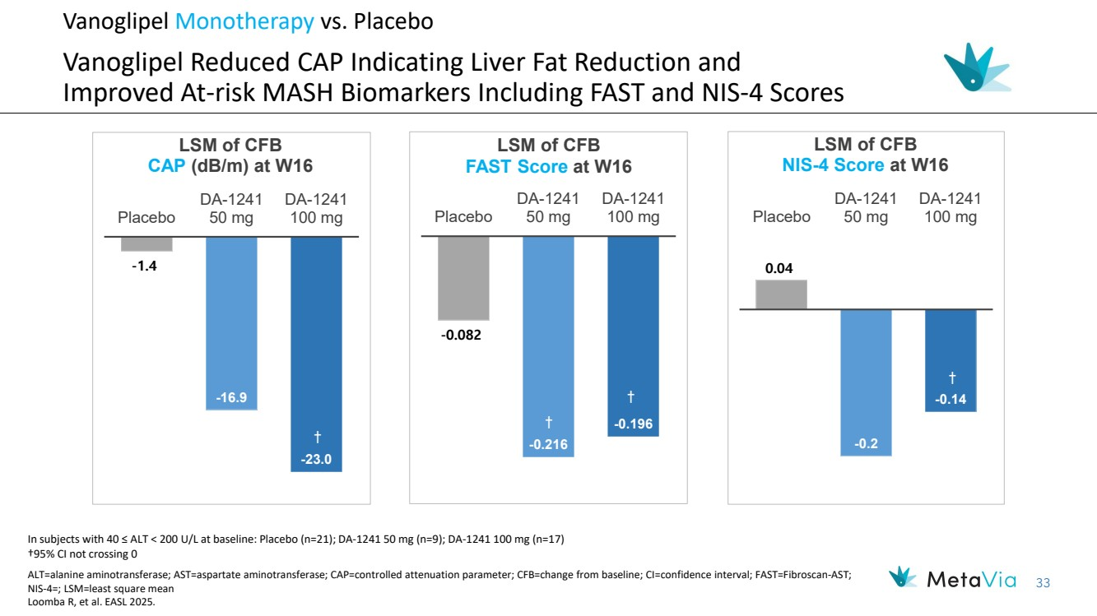 | 33 Vanoglipel Monotherapy vs. Placebo Vanoglipel Reduced CAP Indicating Liver Fat Reduction and Improved At-risk MASH Biomarkers Including FAST and NIS-4 Scores -1.4 -16.9 -23.0 Placebo DA-1241 50 mg DA-1241 100 mg LSM of CFB CAP (dB/m) at W16 † † -0.082 -0.216 -0.196 Placebo DA-1241 50 mg DA-1241 100 mg LSM of CFB FAST Score at W16 † † 0.04 -0.2 -0.14 Placebo DA-1241 50 mg DA-1241 100 mg LSM of CFB NIS-4 Score at W16 † ALT=alanine aminotransferase; AST=aspartate aminotransferase; CAP=controlled attenuation parameter; CFB=change from baseline; CI=confidence interval; FAST=Fibroscan-AST; NIS-4=; LSM=least square mean Loomba R, et al. EASL 2025. In subjects with 40 ≤ ALT < 200 U/L at baseline: Placebo (n=21); DA-1241 50 mg (n=9); DA-1241 100 mg (n=17) †95% CI not crossing 0
 | 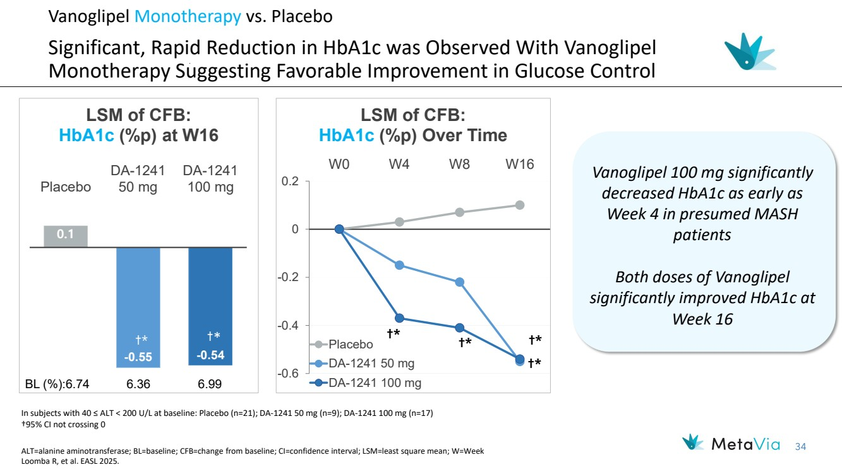 | 34 †* †* †* †* -0.6 -0.4 -0.2 0 0.2 W0 W4 W8 W16 LSM of CFB: HbA1c (%p) Over Time Placebo DA-1241 50 mg DA-1241 100 mg 0.1 -0.55 -0.54 Placebo DA-1241 50 mg DA-1241 100 mg LSM of CFB: HbA1c (%p) at W16 †* †* BL (%):6.74 6.36 6.99 Vanoglipel Monotherapy vs. Placebo Significant, Rapid Reduction in HbA1c was Observed With Vanoglipel Monotherapy Suggesting Favorable Improvement in Glucose Control Vanoglipel 100 mg significantly decreased HbA1c as early as Week 4 in presumed MASH patients Both doses of Vanoglipel significantly improved HbA1c at Week 16 In subjects with 40 ≤ ALT < 200 U/L at baseline: Placebo (n=21); DA-1241 50 mg (n=9); DA-1241 100 mg (n=17) †95% CI not crossing 0 ALT=alanine aminotransferase; BL=baseline; CFB=change from baseline; CI=confidence interval; LSM=least square mean; W=Week Loomba R, et al. EASL 2025.
 | 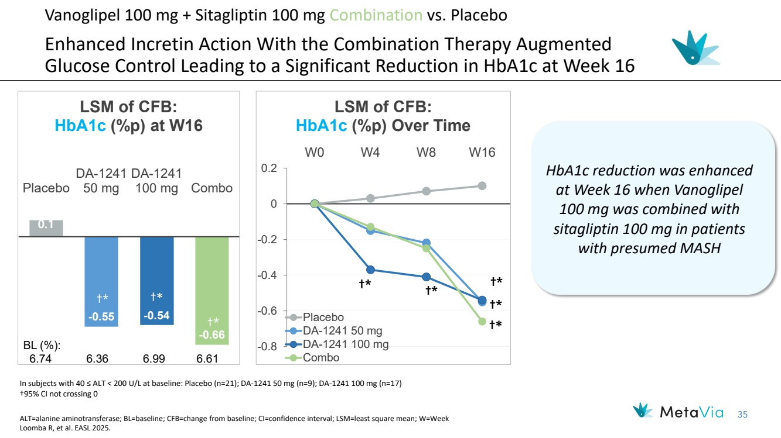 | 35 0.1 -0.55 -0.54 -0.66 Placebo DA-1241 50 mg DA-1241 100 mg Combo LSM of CFB: HbA1c (%p) at W16 †* †* BL (%): 6.74 6.36 6.99 6.61 Vanoglipel 100 mg + Sitagliptin 100 mg Combination vs. Placebo Enhanced Incretin Action With the Combination Therapy Augmented Glucose Control Leading to a Significant Reduction in HbA1c at Week 16 ALT=alanine aminotransferase; BL=baseline; CFB=change from baseline; CI=confidence interval; LSM=least square mean; W=Week Loomba R, et al. EASL 2025. In subjects with 40 ≤ ALT < 200 U/L at baseline: Placebo (n=21); DA-1241 50 mg (n=9); DA-1241 100 mg (n=17) †95% CI not crossing 0 †* †* †* †* -0.8 -0.6 -0.4 -0.2 0 0.2 W0 W4 W8 W16 LSM of CFB: HbA1c (%p) Over Time Placebo DA-1241 50 mg DA-1241 100 mg Combo †* †* HbA1c reduction was enhanced at Week 16 when Vanoglipel 100 mg was combined with sitagliptin 100 mg in patients with presumed MASH
 | 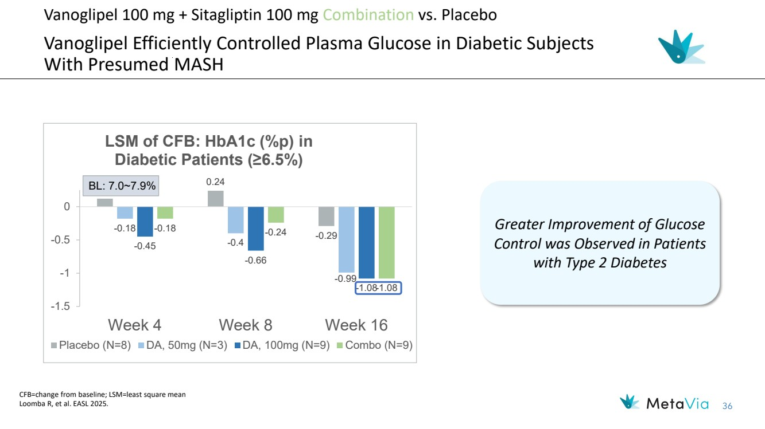 | 36 †* †* Vanoglipel 100 mg + Sitagliptin 100 mg Combination vs. Placebo Vanoglipel Efficiently Controlled Plasma Glucose in Diabetic Subjects With Presumed MASH CFB=change from baseline; LSM=least square mean Loomba R, et al. EASL 2025. †* Greater Improvement of Glucose Control was Observed in Patients with Type 2 Diabetes †* †* †* 0.12 0.24 -0.29 -0.18 -0.4 -0.99 -0.45 -0.66 -1.08 -0.18 -0.24 -1.08 -1.5 -1 -0.5 0 Week 4 Week 8 Week 16 LSM of CFB: HbA1c (%p) in Diabetic Patients (≥6.5%) Placebo (N=8) DA, 50mg (N=3) DA, 100mg (N=9) Combo (N=9) BL: 7.0~7.9%
 | 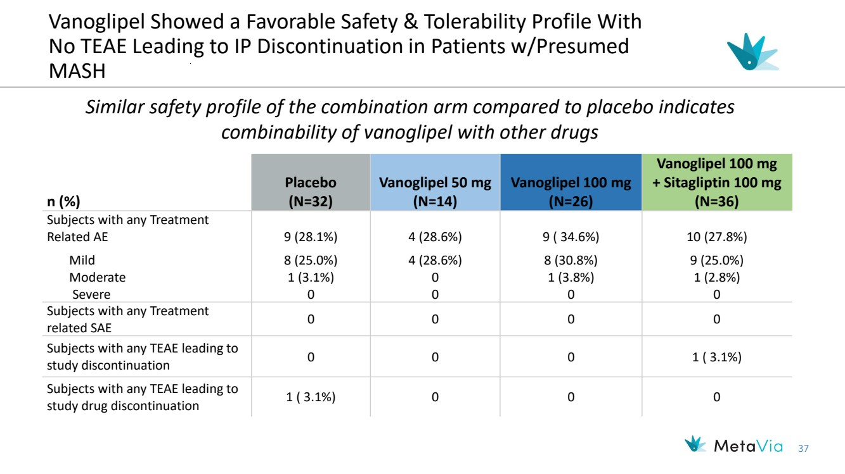 | 37 Vanoglipel Showed a Favorable Safety & Tolerability Profile With No TEAE Leading to IP Discontinuation in Patients w/Presumed MASH n (%) Placebo (N=32) Vanoglipel 50 mg (N=14) Vanoglipel 100 mg (N=26) Vanoglipel 100 mg + Sitagliptin 100 mg (N=36) Subjects with any Treatment Related AE Mild Moderate Severe 9 (28.1%) 8 (25.0%) 1 (3.1%) 0 4 (28.6%) 4 (28.6%) 0 0 9 ( 34.6%) 8 (30.8%) 1 (3.8%) 0 10 (27.8%) 9 (25.0%) 1 (2.8%) 0 Subjects with any Treatment related SAE 0 0 0 0 Subjects with any TEAE leading to study discontinuation 0 0 0 1 ( 3.1%) Subjects with any TEAE leading to study drug discontinuation 1 ( 3.1%) 0 0 0 Similar safety profile of the combination arm compared to placebo indicates combinability of vanoglipel with other drugs

